Values of Rangelands

Multiple Use:
- There are many uses for rangelands and these uses need to be considered simultaneously.
- The Society for Range management defines Multiple Use as “the harmonious use of native rangeland for more than one purpose, such as livestock, recreation, wildlife, and water production.

Livestock Production:
- Livestock production on rangeland is very important:

Rangeland and pastureland in the 19 western states are home to about 58% of all beef cattle, 79% of sheep, and 88% of goats in the US.

Wildlife Habitat
- Rangelands provide habitat for countless mammals, birds, amphibians, fish, and insects.
- Carnivores, Omnivores, and Herbivores
- Grazing wildlife can be categorized into broad groups based on how they forage and their digestion system:
  - _________ have specialized digestive systems to digest the cellulose in the cell walls of rangeland plants.
  - _________ find adequate diet on rangeland by carefully selecting berries, seeds, or roots low in cellulose.
Water
- In the western states, and rangelands are the primary source of water for agricultural, industrial, and domestic use.

Recreation – Increasingly important on rangelands
The USDA National Survey on Recreation show what increases recreation on public lands between 1982-2009? (Draw arrows to connect recreation type to % increase)

- Day Hiking
- Driving off-road
- Fishing and Hunting
- Viewing & Photographing Birds
30%
142%
287%
210%

Renewable Energy - The open landscapes, windy days, and clear skies of rangeland are good for several forms of renewable energy including:

Minerals and Mining - Minerals and mining were historically important resources and are still today an important resource, including:
- _________, _________, ______________
- __________, ____________
- Gold, silver, zinc, cobalt, phosphate

Native Plant Products
- Historically important and harvested today as natural _______ and _______
- Native seed is becoming increasingly stressed in rangeland restoration.

Open Space – Not historically important, but as human populations increased and urban development advanced, it has become highly important to many people.
- A “modern” resource
- Working wilderness
- Scenic easements

Western Heritage – A cultural value of rangelands most Westerners recognize
- The “Western” way of life
- Western Image
- Brand identify
- Native American heritage and culture

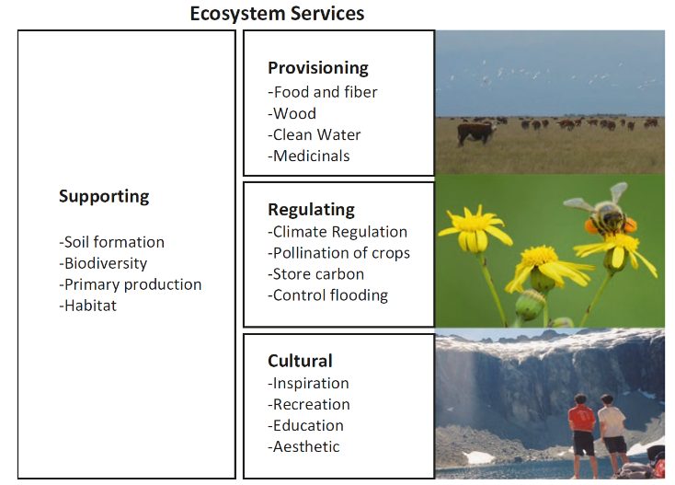
Ecological Services - are the ________________________________________________.

Broadly classified in four different categories:
- _____________
- _____________
- _____________
- _____________

Services can be both local and global.

Different people have different demands or desires for ecosystem services.
- Can lead to conflict and trade-offs:
Livestock-wildlife conflicts
Wind turbines and scenic vistas
- Win-win situations:
Ranching and open space
Hunting and wildlife conservation

Rangeland managers need to manage multiple ecosystem services and their interactions and the demands of multiple beneficiaries.

