What is Rangeland Management?
Rangeland Management is:
- The use and stewardship of rangeland resources to meet goals and desires of humans.
- A Planning Process
- Planning examines different alternatives to see which the “best” future world is.
- What is “best” depends on your point of view.

  - Preservationists
  - Conservationists
  - Utilitarianisms
  - Pragmatists
  - Etc. etc.

What is “Best?”
- Preservationists –
  - Emphasize protecting large areas of land from mining, timber, grazing & development so they can be enjoyed by present and future generations.
  - Founders of the preservation movement were John Muir and Aldo Leopold.
- Conservationists –
  - View land as a resource to be used now to enhance economic growth. But, protected from degradation by efficient management, based on scientific principles, for sustained yield and multiple use.
  - Early conservationists were T.R. Roosevelt, Gifford Pinchot, and John Wesley Powell.
- Utilitarianists –
  - View land as a substrate for saleable products. Management is based on land manipulation and exogenous inputs (e.g., fertilizer or herbicides) are usually required to keep production at an optimum level.
Sources of information for decisions?

Why do we need science?

- T

What kinds of decisions do we make?

- S
- Le s.
Rangeland Management is the use and stewardship of rangeland resources to meet goals and desires of humans.
- What do people want from rangelands?

- What tools do we have for Range Management?
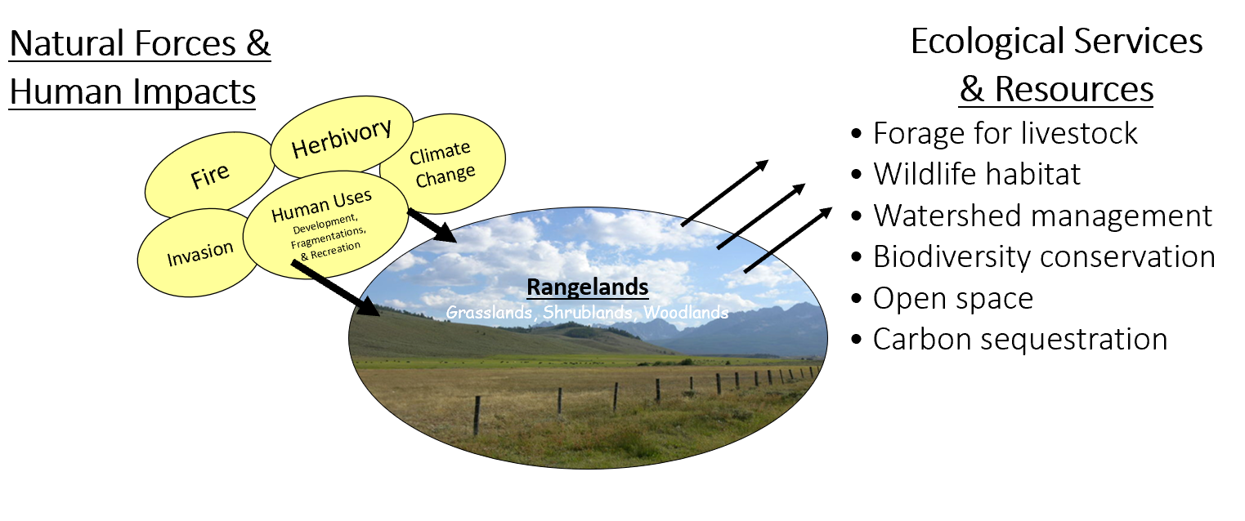on & rehabilitation

Tools of Rangeland Stewardship & Management

Rangeland Management – Basic Concepts
- Rangelands are renewable resources; they can produce on a sustained yield basis if properly managed.
- Managed to maintain soil and water quality and health and basic biogeochemical cycles.
- Managed by extensive and ecological principles, not intensive and agronomic principles.
- Focus on landscape, not one acre.
- Rangelands have a variety of values (e.g., forage, recreation, water) therefore principles of multiple use are important in range management.
- Natural forces and value happen across multiple ownerships (i.e., fire, watershed processes, weeds, open space)
- You can’t please all the people all the time. What one person wants my not meet the desires of plans of another.
- Rangelands change through succession and disturbance. All we can really do as managers is apply, control, or respond to disturbance based on our knowledge of succession.
- The only constant on rangeland is CHANGE. Conditions change from place to place (spatially) and time to time (temporally). We need to understand and accept change.
- If you do nothing the land will probably not return to some natural paradise. The land will change with or without humans.
Many forces that threaten rangeland integrity!

- Unsustainable grazing practices
- Damaging fire regimes
- Invasive plant species
- Global climate change
- Human development
- Disease and insect damage

