History of Rangeland Management
Era of Rangeland Management:
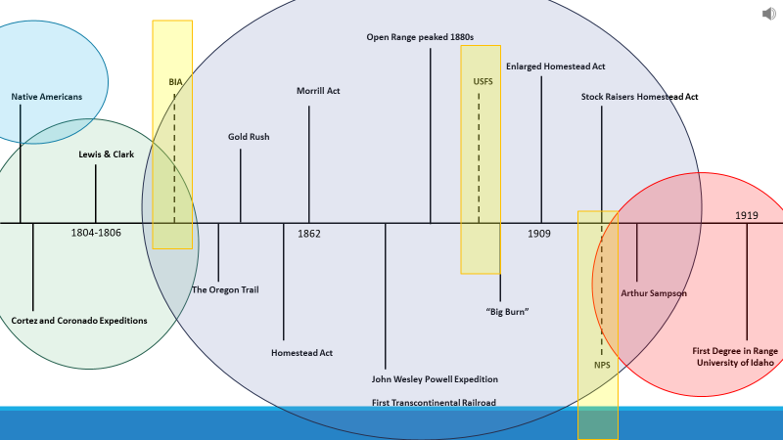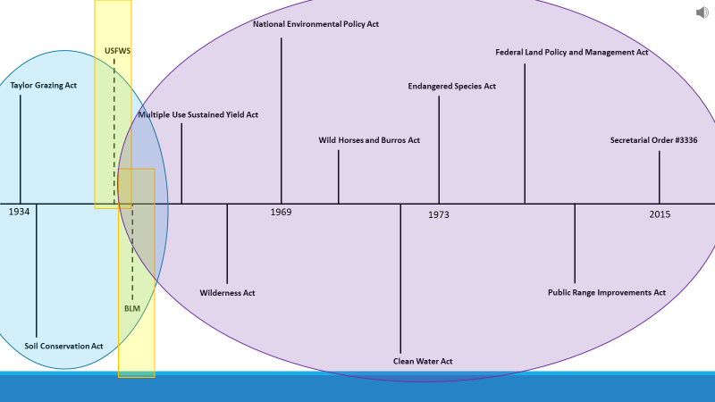

Native Americans
- Land for survival and resources -
- Wild Horses -
- Use of Fire –

Explorers & Trappers
- Cortez (1515) and Coronado (1540) –
- Lewis & Clark (1804-1806) –

Settlers & Pioneers
- Oregon Trail (1840-1860)
- Gold Rush (peaked in 1852)
- Homestead Act (1862)
  - _____ Acres
  - U.S. Citizen =
  - At least _____ years to “prove up”
- John Wesley Powell Expedition started in _________
- Enlarged Homestead Act of 1909 = ________ acres
- Stock Raisers Homestead Act of 1916 = _____ acres or ______ cows
- Morrill Act of ______ established _______ ________ Colleges like the University of Idaho, Montana State University, Colorado State University, Utah State University and others across the west.
- Open Range
  - Transcontinental Railroads
  - Mining
  - Tragedy of the Commons
  - Range Wars
- Big Burn of 1910

Beginning of Range Science
- _________ ________the “Father of Rangeland Ecology”
- First degrees in rangeland ecology and Management 1919-1940

Birth of Public Land Management
- Bureau of Indian Affairs (BIA) – established in ______
- US Forest Service (USFS) – established in ______
- National Park Service (NPS) – established in ______
- US Fish and Wildlife Service (USFWS) – established in ______
- Bureau of Land Management – established in ______
- Taylor Grazing Act of _____ accomplished 2 major objectives:

- Soil Conservation Ac to ______ create the ____________ Agency
- Bureau of Land Management (BLM) formed when the __________ _________ Office joined with the U.S. _________ Service

Environmental Policies Era from 1960 to Now
- Multiple Use Sustained Yield Act of _____
- Federal Land Policy and Management Act of _________
- Wilderness Act of __________
- National Environmental Policy Act of __________
- Wild Free-Roaming Horses and Burros Act of ________
- Endangered Species Act of ______
- Clean Water Act of _______
- Public Range Improvement Act of ______ accomplished several tasks including:
  - Set a fee for __________
  - Ensured protection of _______________
- Secretarial Orders = issued to set direction for agencies. For example:
  - Order 3336 =
  - Order 3363 =
  - Order 3354 =

