Plant Response to Grazing
Plants use to strategies to deal with defoliation (i.e., grazing or mowing)
1) Defend yourself to AVOID being grazed
2) Be able to survive and TOLERATE grazing
Avoid – Thorns, Spines & Awns
- Slow down intake
- Cause pain
Avoid – Toxins and Anti-Quality
- Kill animal
- Make animal sick
- Cause pain
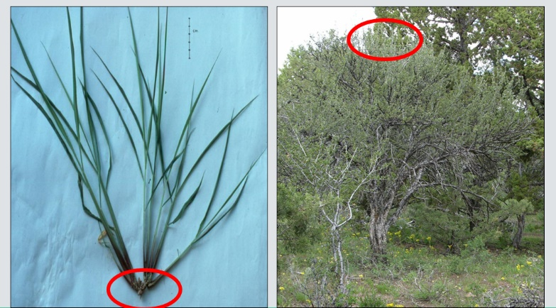
Tolerate Defoliation - Response Depends On:
- Location of Growth Points
Meristems = growth points for new leaves and stems

- Resources for recovery
  - Moisture
  - Nutrients
  - Time
SPRING better than FALL

MOIST better than DRY

- Carbohydrates (Energy) for Regrowth
  - Leaves photosynthesize and create energy
  - Some energy stored in roots

