US Rangelands
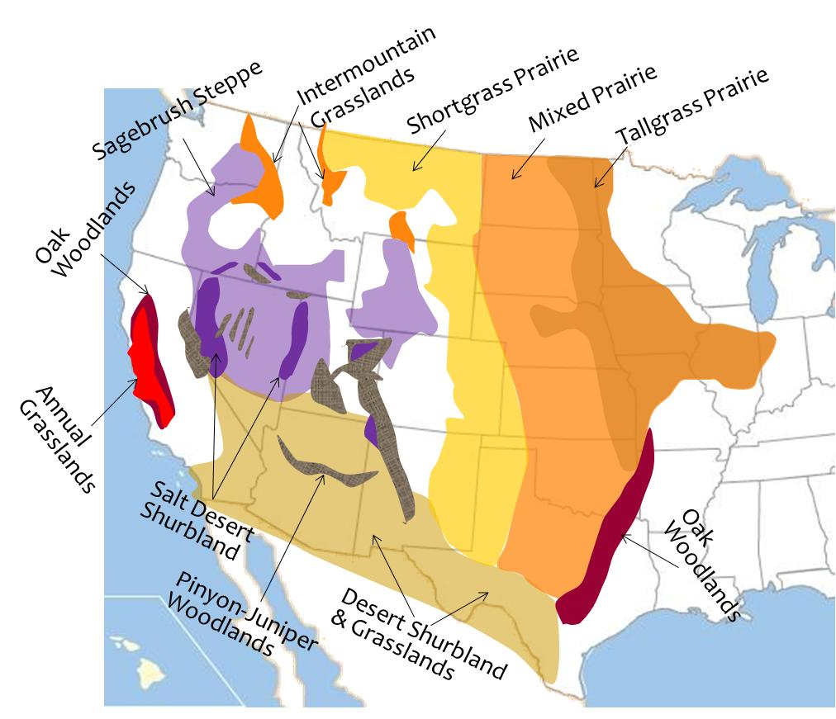
Biomes of US: Grasslands & Savannas, Deserts & Semideserts, Mediterranean

Climate Regions: Great Plains, Pacific NW, Great Basin, Mediterranean, Southwest Desert

Pacific & Great Basin

Mediterranean:
- Annual Grasslands

- Oak Woodlands

Pacific Northwest:
- Intermountain Grasslands

Great Basin:
- Sagebrush Steppe

- Salt Desert Shrub

- Pinyon Juniper Woodlands

