US Rangelands
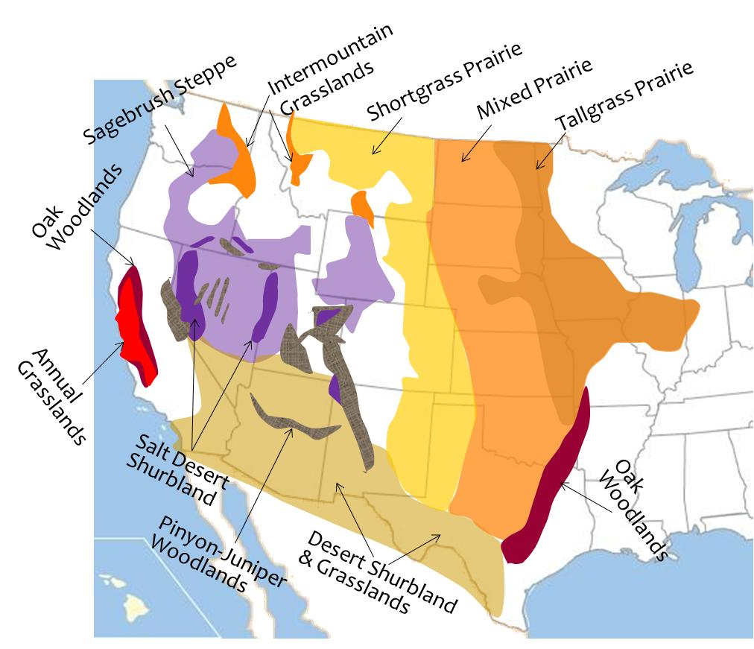
Part 2 – Great Plains and Southwest Deserts

Great Plains:
- Shortgrass Prairie

- Mixed Prairie

- Tallgrass Prairie

Southwest Desert:
2 types of Cold Desert & 2 types of Hot Desert
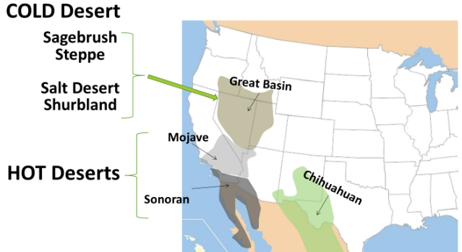
Hot Desert:
- Mohave with ___________
- Sonoran with ___________
- Chihuahua with ____________ & _____________

