Matching Forage Supply with Animal Demand
REM 456 – Integrated Rangeland Management – University of Idaho

The Big Picture

Maintain healthy rangelands and healthy animals.

Generate income for family and community.

Forage production is driven by temperature, soil characteristics, and plant residue—changes from year to year

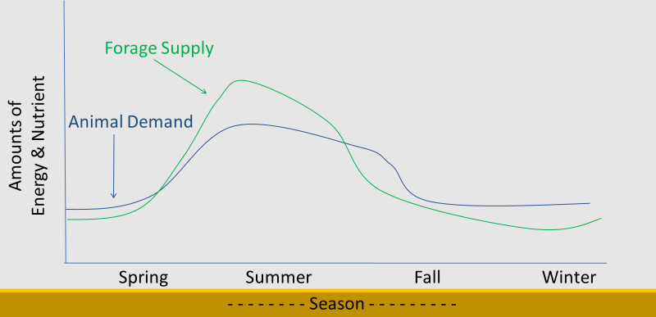
Must understand the system to produce healthy and productive rangelands.

Dry Matter Intake (DMI) –
- Animal consume approximately ____ % of their BW on a Dry Matter (DM) basis
Spanish goat, Blackbuck Antelope, and calf (<100 lb) ~ 4% DMI Fallow deer, Sheep, Mule deer, White-tailed deer ~ 3.5%
Beef cattle 1,000-1,500 lb ~ 2.0%
- Example: If a 200 lb Mule deer consumes ~3.5% of their body weight on a DM basis, they will consume lb of plant material on a DM basis

How to Meet Demand
Stock Conservatively –
- More forage for each animal to choose from:
  - ____________________________________________
  - _____________________________________________
- Reduces energy required to find adequate diet.

Timing -

- _____________________________________
Native animals already do this through natural selection
- _________________________________________________
Animals moving up in elevation as season progresses
  - _________________________________________________
Stocking steers during growing season vs year-round cow/calf?

- ___________________________
Winter forage?

Manipulate vegetation to meet animal needs.
- ______________________________- To provide abundant high-quality forage during a season.
For example:
- Crested wheatgrass provides good spring/fall grazing because of its growth pattern.
- New rye grasses developed to maintain energy and even protein values well into winter.
- Manage for: _______________________ supply protein and phosphorus during dormancy. For example:
- Shrubs on mountain benches for deer winter habitat.
- Grazing by cattle to reduce grass biomass so that shrubs will grow.
- Manage for: ___________________
o Seasonal forage supply is improved as plant diversity increases because plant mature at different rates and have different levels of nutrients.

How do grazing animals cope with period of low forage quality?
•
- Grazing animals with good fat reserves can survive 30-60 days with little or no food consumptions.
- Mule deer does with high levels of fat reserves have survived complete starvation up to 64 days.
- Fat supplies energy and vitamin A which stored in fat.
- Native animals lower their metabolic rate and consequently lower energy requirements.
- Nitrogen recycling in ruminants
  - Some of the nitrogen that gets absorbed out of the rumen is put in saliva where it goes back into the digestive system, for possible absorption, instead of being lost in urine.
- can play a critical role in permitting ruminants to meet critical mineral needs.

SUPPLEMENTATION
- Energy - rarely economical to supplement.
- Major operations expense confronting the range livestock industry.
- Rarely economical to supplement.
- When energy is supplemented, use of range vegetation generally decreases.
- - generally impractical on rangelands except under drought and heavy snow.
Can be used effectively for young animals in a creep feeder.
- - Hay or straw is only necessary to supplement when animals cannot meet daily dry matter requirements on rangeland (winter and drought). Remember hay or straw is basically an energy source – i.e., cellulose.

- Protein (or Nitrogen) - Use of range may increase with nitrogen supplementation.

Non-Protein Nitrogen
  - Lower cost than true protein, made into protein by rumen microbes.
  - Can be used to meet about 1/3 total protein requirements.

Summary
- High-protein feeds -
  - Protein supplementation important when crude protein values of range forage falls below 6%. Because below 6%, rumen microbial growth is inhibited and structural CHO's cannot be adequately digested.

    - Plant quality as a nutritional source decreases as the plant matures
    - Animal nutritional demand changes throughout the year and depends on where the animal is in production (i.e., growing, lactating, fattening, gestating)
    - Meet demand by timing nutrient supply with animal demand
    - Manage land to increase diverse vegetation to meet animal needs
    - Wildlife can lower their metabolic rate to limit energy expenditure when plant nutrients are scarce
    - Supplementation may help meet animal demand but is costly.

