Herbivore Intake
REM 456 – University of Idaho – Karen Launchbaugh
Based on: Understanding Forage Intake in Range Animals. 1999. by Lyons, Machen & Forbes. Texas A&M Extension Bulletin E-393.

Factors Affection Herbivore Intake

- Herbivore Species & Size
________________
- Physiological State

- Forage Quality
- Forage Water Content
________________
- Forage Characteristics & Foraging Behavior

- Supplemental Feeding
________________
- Standing Crop
- Environmental Factors

Herbivore Species – Ruminants vs Hind-gut Fermenters
- Three major difference between cows and horses affect their intake and nutritive status:

- In Summary:
  - Horses have faster rate of passage
  - Horses eat about 70% more than ruminants of the same weight.
    - 1,000 lb cow eats about ___ pounds per day
    - 1,000 lb horse eats about ___ pounds per day
  - Cattle can digest rumen microbes for protein and vitamin B
Herbivore Size
- Intake of range herbivores varies from 2 to 4% of body weight consumed per day.
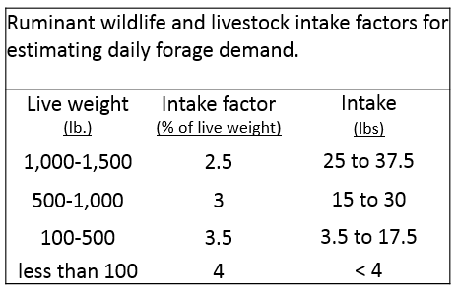
  - This “_________ _________” predicts amount of dry matter eaten per day as a % of live body weight.
- Smaller herbivores eat a greater proportion of body weight per day.
  - Smaller animals have greater nutrient requirements per pound of body weight than larger.
  - Smaller herbivore select higher quality more digestible diet (i.e., leaves over stems).

Physiological State
- Greatest nutrient demand and intake during lactation
  - Can eat _____ to ______% more forage when lactating than when dry

- Intake generally declines in late gestation:
  - Fetus may take reduce space for rumen
  - High estrogen levels may reduce appetite

Forage Quality
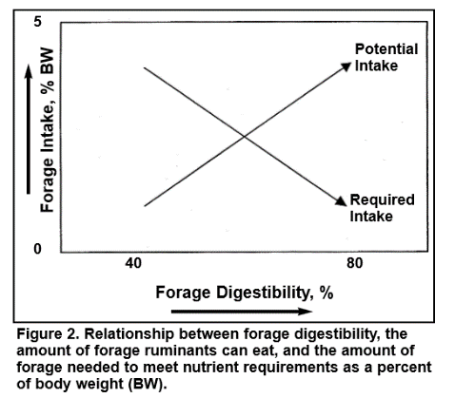
- Yes,
  - Higher nutrient value & digestibility means animals need to eat less to meet demand.
- But,
  - Higher nutrient value & digestibility means forage is quickly digested and animals are able to eat more.
- Therefore,
  - Intake ___________ as forage quality __________
Water Content
- Often thought that high water content can reduce intake
  - Not true
  - Water is generally easily absorbed
- Low intake early in the spring
  - Due to limited forage available
  - Not because of high moisture in forage

Forage Characteristics & Foraging Behavior
- Moist leafy material more palatable and more easily eaten than dry stemmy forage.
- Forages that provide larger bite size and greater bite rate afford great intake
- Anti-quality compounds in forage can make animal nauseous and can reduce intake or halt foraging.

Supplemental Feeding
- Protein:
  - Low protein settings → Supplementing protein (or nitrogen) can improve growth of rumen microbes and generally ___________ intake.
  - Higher protein settings → Supplementing protein (or nitrogen) will _______ intake of other forages.
- Energy:
  - Low energy settings → Supplementing energy will help meet animal demand but animals will continue foraging (_____ effect on intake)
  - Higher energy settings → Supplementing energy will “substitute” for forage and ________ intake.

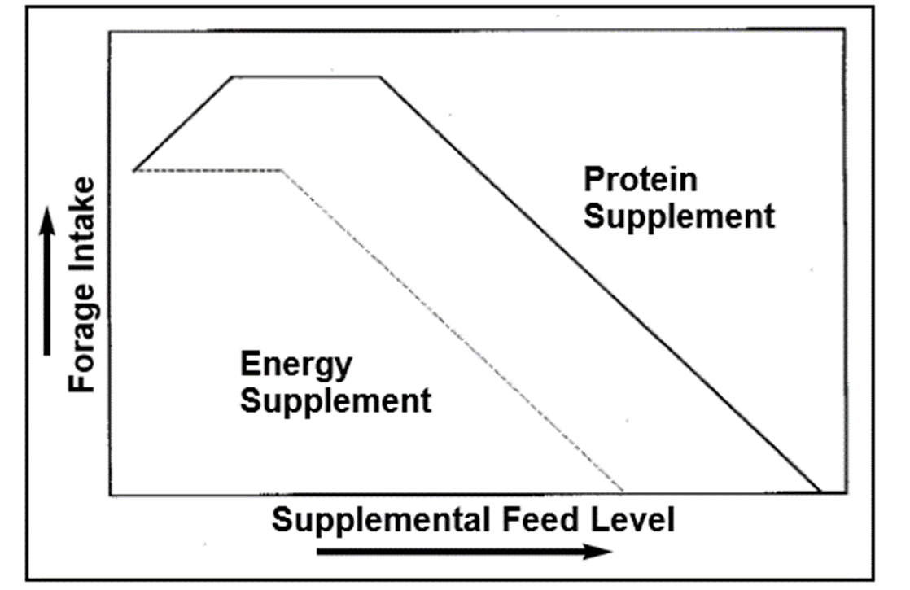
Forage Standing Crop & Forage Allowance
- Forage Quantity can affect intake
  - Standing crop > 2,500 lbs/acre = __________ on intake
  - 2,500 to 1,000 lbs/ac = _________ intake
  - <1,000 lbs/ac = rapidly ________ intake
- Forage Allowance = Amount of forage available per animal (lbs of forage/100 lbs animal weight)
  - More relate to intake than standing crop
  - Forage Standing Crop

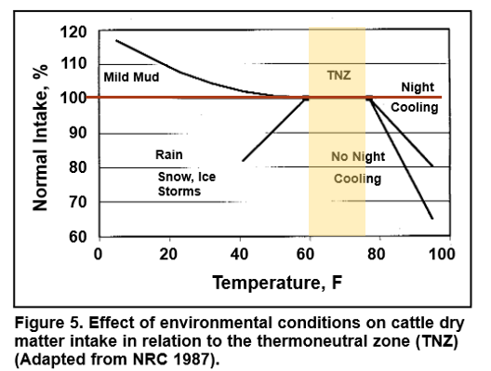
Environmental factors affect intake
- Cold temperatures
  - Increase demand and intake
  - Can reduce intake if snow, ice, or storms limit ability of animal to forage
- Hot temperatures
  - Decrease intake
  - Night cooling & foraging at night can improve intake in hot season

Conclusions – Intake affect
- Many characteristics or factors affect intake:
  - ______________
  - ______________
  - ______________

- Understanding forage intake is important, because it affects animal nutrient status.
- Estimates of intake on a yearly basis (i.e., 2.5% of BW/day throughout year) are gross averages that gloss over true variation.

