Grazing Systems ~ for rangeland management
- REM 456 – University of Idaho – Karen Launchbaugh

What management goals can be reached with grazing systems?
- Maintain or accelerate improvement in vegetation and facilitate proper use of the forage on all grazing units.
- Improve efficiency of grazing through uniform use of all grazing units.
- Stabilize the supply of forage throughout the grazing season.
- Enhance forage quality to meet livestock and wildlife needs.
- Improve the functioning of the ecological processes.
- Improve watershed protection.
- Enhance wildlife habitat.

Grazing methods/systems cannot:
  - Rectify mismanagement because of:
    - Wrong species or class of animal
    - Incorrect stocking rate
    - Major distribution problems because of water avail or topography
  - Achieve range improvement in plant communities that are dominated by long-lived woody plants.

Major Types of Grazing Systems:
- Continuous and Season-long Grazing
  - Describes as (in your own words):

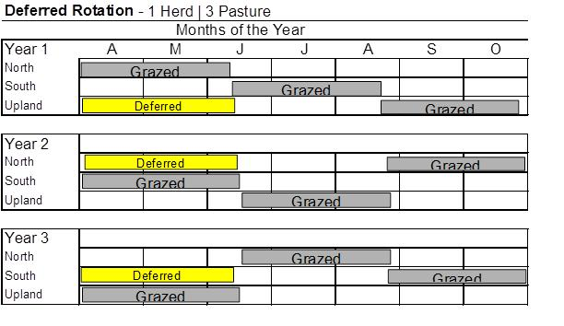
- Deferred Rotation
  - Described as:

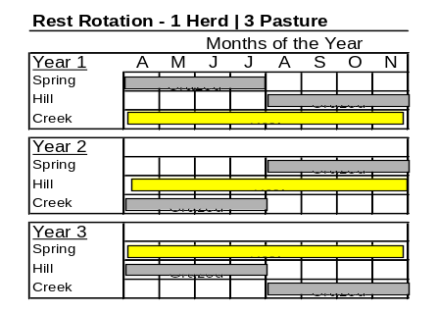
- Rest Rotation Grazing (a.k.a., Hormay System)
  - Described as:

- Intense Rotation Systems (Short Duration or High Intensity/Low Frequency)
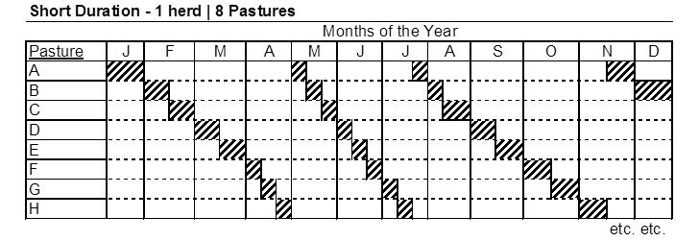
  - Describe in words:

- Decisional Methods
  - Best-pasture system
    - Move livestock to pasture that looks the "best" in terms of forage availability
    - Designed for arid areas where rain may improve forage on one part of a ranch but not affect another part.

  - Complementary system
    - Designed in the central prairies where animals rely on cultivated or improved pastures for part of the year and then are moved to native range.

  - Seasonal-suitability
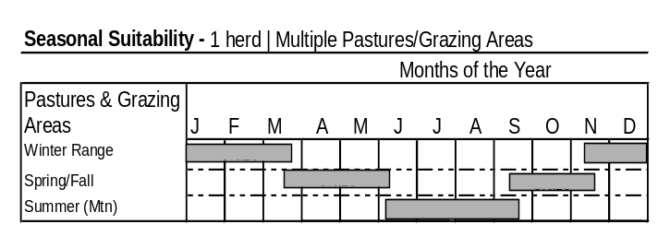
    - Movement of livestock to different areas of range depending on the growth patterns of different vegetation types.

- Which system would give the best animal performance and why?
- Which system would be best to improve riparian areas and why?
- Which system would be most beneficial to wildlife populations and why?
- Which system would be easiest to adjust if a wildfire went through the range, and why?
There is no one-size-fits-all grazing system:
- Depends on the skill of the manager. Nearly all of these systems will work with a well skilled manager.
- There are thousands of variations on a theme. The exact ways that rest, deferment, grazing, and rotation are combined can create new and appropriate systems.
- No matter the system – stocking rate, species of grazing animal, and distribution patterns are very important in determining how the systems affect vegetation communities.
- All systems need to be flexible to manage unexpected disturbance such as fire or weed invasions.

