Integrated Weed Management ~ An Ongoing Battle
- REM 456 – University of Idaho – Karen Launchbaugh

Why Care? Because the spread of noxious weeds:
- Signal the decline of entire ecological watersheds.
- Severely impact the beauty and biodiversity of natural areas and cause widespread economic losses.
- Problem for urban as well as rural areas, and for private, state, and federal lands.
- Noxious weed species spare no segment of society—rancher, farmer, fisher, and cycler alike
- Can’t leave well enough alone - when unmanaged, they spread rapidly, unceasingly, and silently

Several scientists who focus on the ecological effects of global change consider invasive species the most serious threat, more serious than global warming or ozone depletion. While global warming and ozone depletion have serious implications, they are reversible. Once a noxious weed species is widely distributed it is virtually impossible to remove it, making their effect on the environment permanent.
Invasive Species

  - plants
  - animals
  - microbes (fungi, bacteria, etc.)
  - viruses (i.e., diseases)

Invasive Species Website = https://www.invasivespeciesinfo.gov/

Terminology – as applied to plants
  - Weed
  - Exotic, Alien, Introduced or Nonindigenous
  - Invasive Plant
  - Noxious Weed

- What is a Weed?
  - Plant of little value
  - Plant “out of place”
  - Species that competes with crops and native species
  - Troublesome pest that affects the health of livestock and wildlife
  - “plants that interfere with the growth of desirable plants and that are unusually persistent and pernicious. They negatively impact human activities and as such are undesirable”
(Ross & Lembi – Applied Weed Science. 1999)
- Noxious = plant species that have been designated “noxious”by law.
  - “Noxious” simply means deleterious, and all listed weeds are deleterious by definition.
  - When “Noxious” is applied to weeds it has a specific meaning
    - The plant that have been designated “noxious” by law – the Noxious Weed Act of 1974.
  - Weeds are declared NOXIOUS by counties, regions, states or the U.S.
- Noxious Weed Law - Requires several basic actions for Local, State & Federal agencies:

Designate adequately trained person to oversee weed control programs
  - Es
tablish budgets for weed control
  - I
ndividuals must control noxious weeds on their land or face fines
  - Establish process for cooperative agreements among land owners.

- An Example - Idaho’s Noxious Weeds
  - Idaho has 67 different species of weeds which are designated noxious by state law.
  - The Idaho Department of Agriculture oversees Idaho Noxious Weeds actions
  - The following criteria for designation of a noxious weed:
    - It must be present in but not native to Idaho.
    - It must be potentially more harmful than beneficial to Idaho.
    - Eradication must be economically and physically feasible.
    - The potential adverse impact of the weed must exceed the cost of control.
  - Many Noxious Weed categorized plants in levels of concern such as:
    - Early-Detection, Rapid-Response (EDRR)
    - Control
    - Containment
  - The spread of these weeds and the damage they cause can be lessened through proper identification and handling.
  - Idaho's Noxious Weeds, 7th Edition
    - Covers all 67 weeds on Idaho's official noxious weeds list:
http://www.extension.uidaho.edu/publishing/pdf/BUL/BUL816.pdf

- Exotic, Alien, Introduced or Nonindigenous
  - Not from ‘round here
  - Not native to a region and have been brought in either by accident or for a specific purpose.
  - Idaho has about 800 exotic species
  - How Introduced Plants Get Here? - Human actions are the primary means of invasive species introductions.
    - Grains and Feeds
    - Ship Ballast and Shipping Contents
    - Ornamentals
    - Erosion Control
    - Forage Value
    - Accidental
- Invasive Plant
  - Once established, invasive species will out-compete native species and often spread and dominate wildland plant communities.
  - Exhibit “weedy” or aggressive growth characteristics
  - Can be grasses, forbs, shrubs, or trees
  - Native or exotic
  - Characteristics of Invasive Plants
    - Abundant seed producers
    - Rapid population establishment
    - Long-term survival of seeds
    - Occupy disturbed sites
    - Competitive
    - Lack of natural enemies
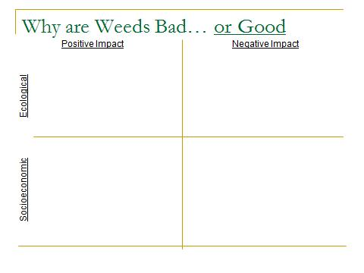
- Land Management and Invasion
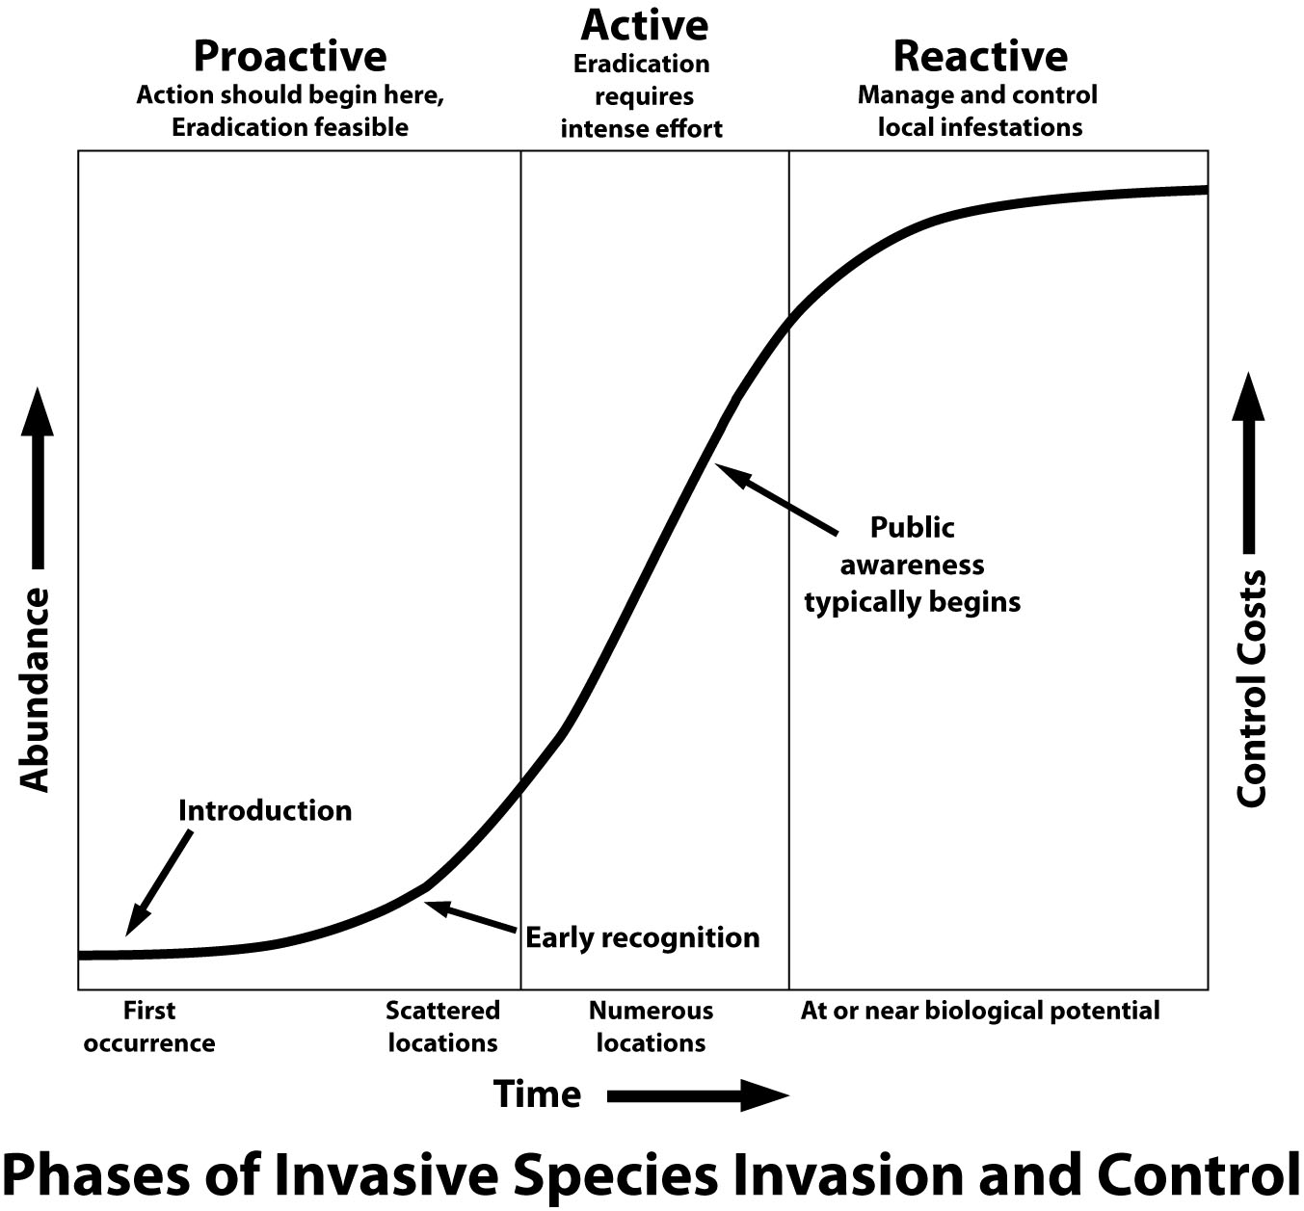

- Land Planning With Weeds
  - Maintain healthy natural plant communities
  - Prevention
    - Consider vectors of introduction
    - Develop plans to minimize introduction
    - Minimize disturbances that may favor weeds
  - Early Detection
    - Develop strategy for early detection
    - Eradicate when possible
  - Weed Survey
    - Collect information about weed biology and ecology.
    - Document growth requirements
    - Identify sites susceptible to invasion
    - Evaluate progress of weed management plan
  - Weed Mapping
    - Delineate extent
    - Document control activities

  - Monitoring and Evaluation
    - Was weed population adequately suppressed?
    - Was cost of suppression acceptable?
    - What were non-target effects?
    - Should treatment be repeated or modified?Monitory spread overtime
- Integrated Weed Management
  - Coordinated Weed Management Groups
  - Develop plans across land ownerships
  - Leverage resources
    - Time
    - Equipment
    - Money

  - Apply for state and fedearal fundsExpertise
Apply for state and federal fundsmanagement goals met?
REMEMBER – It is not only about the WEED… it is about the LAND

