Grazing Methods ~ Setting the Fpundation
- REM 456 –Integrated Rangeland Management - University of Idaho
Basic Principles of Grazing Methods
Grazing Principles
- Which animal(s)? ___________________
- How many animals? __________________
- When to graze or not graze? _________________
- How long to graze or rest? ____________________

Basic Principles of Grazing Methods
- Grazing methods (or systems) are controlled grazing management practices that manipulate livestock to systematically control periods of grazing, deferment, or rest.
  - Deferment = ________________________________________________________________

  - Rest = _____________________________________________________________________

- Season of Use = __________________
  - Yearlong - __________________________________________________________________
  - Season - __________________________________________________________________
__________________________________________________________________
  - Rotation - _________________________________________________________________
- Grazing Season vs Growing Season
  - Rangelands –
    - Requires stockpiling forage for use during the dormant season.
    - Frequently involve light use during the peak growing season.
  - Tame Pastures –
    - Stockpiling forage by shortening the grazing period during active growing.
Grazing Methods (or grazing systems):
- Controlled grazing management practices that manipulate livestock to manage periods of grazing, deferment, or rest.
- Designed to control the effects of grazing at the individual plant level by controlling:

  - Season of grazing
Timing of Grazing – Effects of grazing varies according to:
- Season of Use & Phenological Stage
Plants are more resistant to intense herbivory during dormancy than during active growth.
- Opportunity for Re-growth
Will plants be able to produce new leaves and develop strong root systems prior to entering dormancy following defoliation?

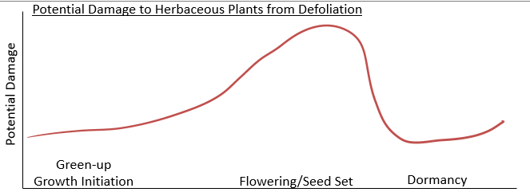
It is extremely important to select the appropriate season of grazing or rest:
- Grazing during dormant season is least damaging (except for shrubs).
  - At this time, the plant is not actively photosynthesizing and plant does not try to re-grow after being grazed. However, grazing during this time may be detrimental to shrubs that are maintaining and forming buds which are accessible to herbivores.
- Grazing when plants initiate growth has intermediate negative effect.
  - The plant is actively growing and has significant demand for photosynthetic products. However, the conditions for growth are optimal (i.e., plenty of soil moisture and nutrients). This active photosynthesis can provide the carbohydrates (CHOs) necessary for growth. During drought years this period of effective soil moisture may be limited, and grazing may be detrimental until the plant becomes senescent.
- Grazing during flower initiation through seed developments is most damaging.
  - During this time, the plant’s demand for soluble CHO’s is considerable as the plant is near peak biomass (i.e., has a lot of biomass to support) and is using CHO’s for seed development. Defoliation can also be detrimental during this time because the conditions for active photosynthesis are less favorable (i.e., less soil moisture, higher temperatures) and there is less time in the growing season to recover from defoliation.
Objectives for good grazing method:
- Maintain forage plant vigor
  - allowing plants to produce seeds
- Meat animal production goals
- Maintain soil health
- Uniform or patchy utilization patterns
  - depending on land management goals

Steps in a Grazing Management Plan:
- Research past grazing history and issues
- Determine current conditions & resources
- Identify goals and concerns of land owner
- Consider grazing strategies to address goals & concerns including other land mgmt. goals:
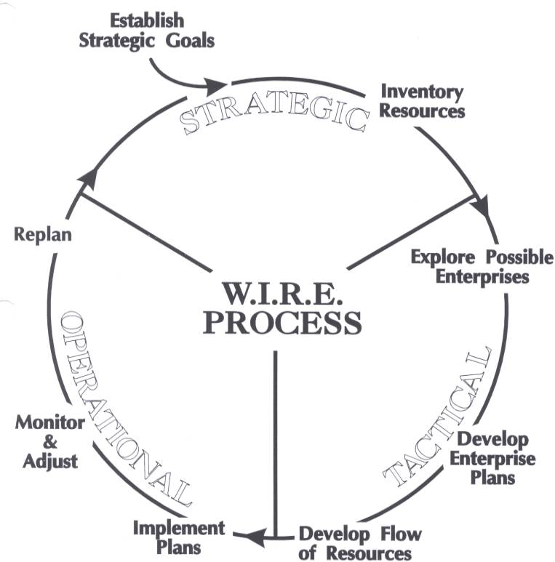
  - Wildlife
  - Fire
  - Weeds
  - Water
- Develop grazing plan
  - of animal
  - s

- Consider laws and policies
  - clean water act
  - endangered species act
  - agency policies (i.e., NEPA)
- Re-evaluate plan throughout season and adjust on regular basis

