Diet Selection-Preferences & Aversions
Integrated Rangeland Management – REM 456 – University of Idaho

Palatability vs Preferences
- Palatability = “attractiveness” of a plant as forage
- Preference = selection of a plant give a choice

Both are an interrelationship between flavor and post-ingestive feedback from nutrients and toxins::
- an animal’s physiological condition
- a food’s chemical characteristics
- an animal’s experiences with the food

Principles
- Palatability depends on feedback
- Animals can detect positive feedback (nutrients & energy) and negative feedback (anti-quality factors & toxins)
- Animals discriminate based on flavor-feedback interactions

Post-Ingestive Feedback
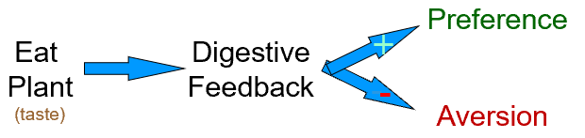
Animals are built to link Flavor to Feedback
This detection ability is simply the result of the way the body is constructed.

Flavor & Positive Digestive Feedback
Conditioning Group 1 Group 2
odd days Onion Straw Oregano Straw
+ water + water
even days Oregano Straw Onion Straw
+ starch + starch
-----------------------------------------------------------------------
Testing = choice between Onion or Oregano flavored straw. - What flavor did Group 1 prefer?

Energy Increases Palatability
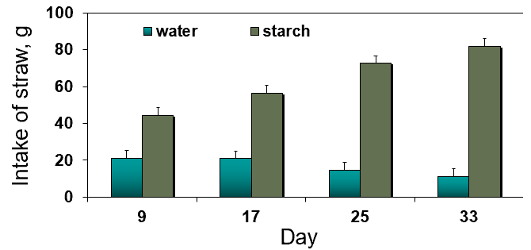

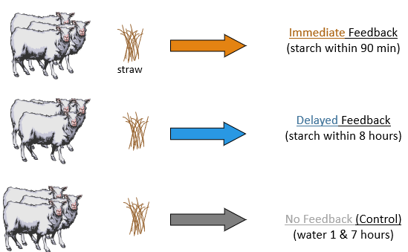
Conditioned Preference
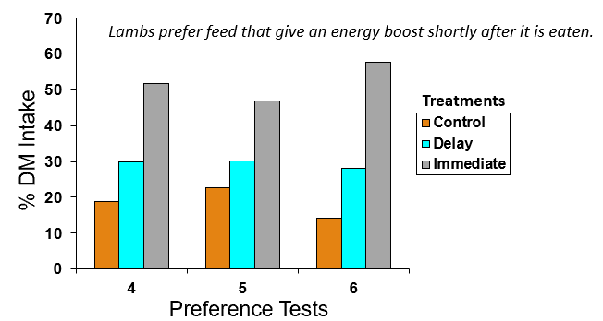

Conditioned Aversion
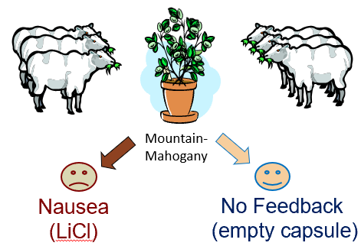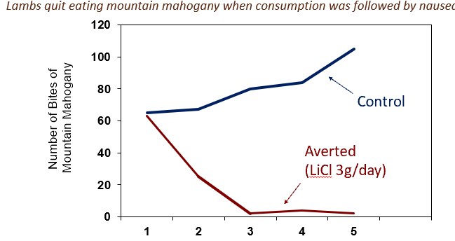

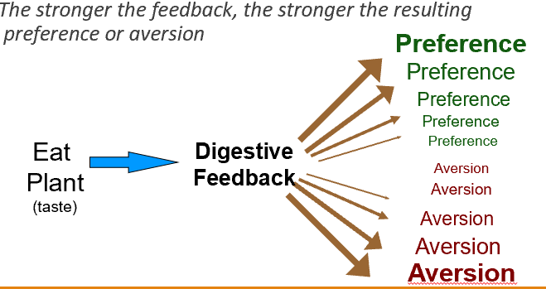
Principle – Magnitude Matters Stronger Feedback = Stronger Aversion

- www.BEHAVE.net

- References:
- Burritt, E.A. & F.D. Provenza. 1989. Food aversion learning: conditioning lambs to avoid a palatable shrub (Cercocarpus montanus). J. Anim. Sci. 67:650- 653
- Du Toit, J.T., F.D. Provenza, & A. Nastis. 1991. Conditioned taste aversions: how sick must a ruminant get before it learns about toxicity in foods? . Appl. Anim. Behav. Sci. 30(1):35-46.
- Launchbaugh, K.L., F.D. Provenza & E.A. Burritt. 1993. How herbivores track variable environments: Response to variability of phytotoxins. J. Chem. Ecol. 19:1047-1056.
- Smith, E. 1999. Carbohydrate Availability Impacts Dietary Preferences by Sheep. M.S. Thesis. University of Idaho, Moscow, ID
- Villalba, J.J. & F.D. Provenza. 1997. Preference for wheat straw by lambs conditioned with intraruminal infusions of starch. Br. J. Nutr. 77:287-297.

