Grazing Management After Fire
- REM 456 – Integrated Rangeland Management – University of Idaho
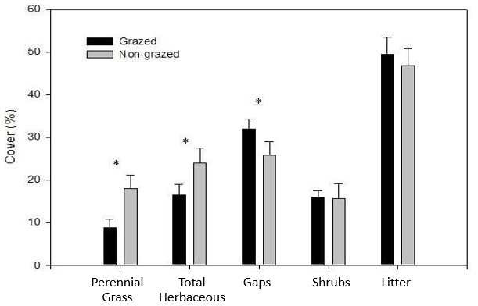
- Grazing before fire affects:

- Animals are drawn to recently burned areas. Why?
  - Increased forage ____________ after fire
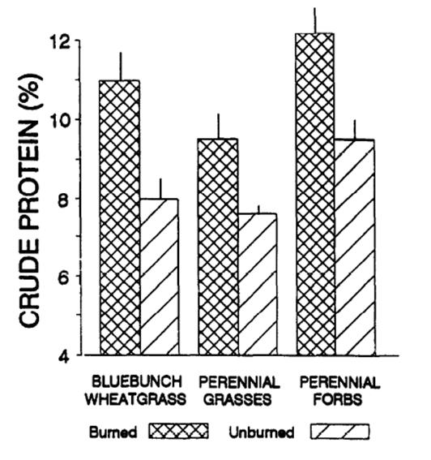
  - Increase forage _____________ after fire
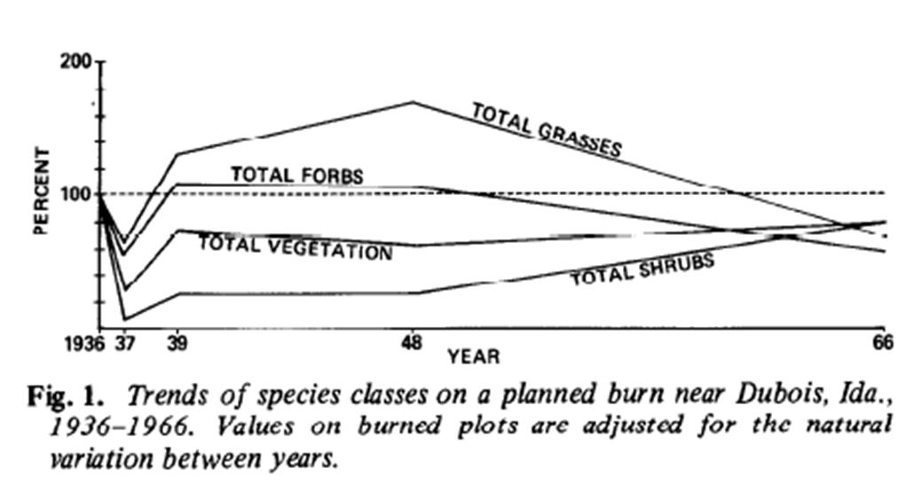
Grazing After Fire
  - Concern about recovery of plant community after fire
  - Is rest after fire ecologically significant?
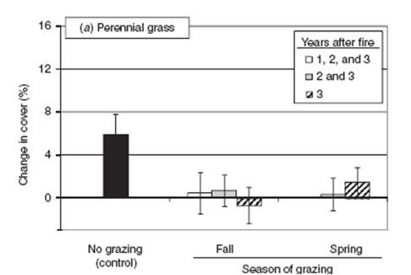
  - Don’t forget invasives -- especially annual grasses

Sagebrush Steppe Study – Grazing After Fire Study
- Research Results:
  - No effect of grazing after fire on Annual Grasses
  - No effect of grazing after fire on recover of Perennial Forbs
  - No effect grazing on recover of Perennial Grasses, overall
  - Grazing in spring & fall after fire slowed recovery of Bluebunch Wheatgrass

- Delay of grazing after fire? It depends
  - Pre-fire vegetation community
  - Fire severity
  - Presence of invasive species – rest from grazing after fire could promote weeds
Don’t forget:
  - Hardship on land managers & livestock owners
  - May create fuel loads for subsequent fires

- Role of Grazing in Restoration?

