Diet Selection ̶ Social Models
Integrated Rangeland Management – REM 456 – University of Idaho

Social Models for Learning

Mother is most important social model
- _______________________________________
- _______________________________________
- _______________________________________

Lambs eat what mom eats – Video https://youtu.be/XaBlKDXewrU

Lambs learn quickly from mother and remember for years
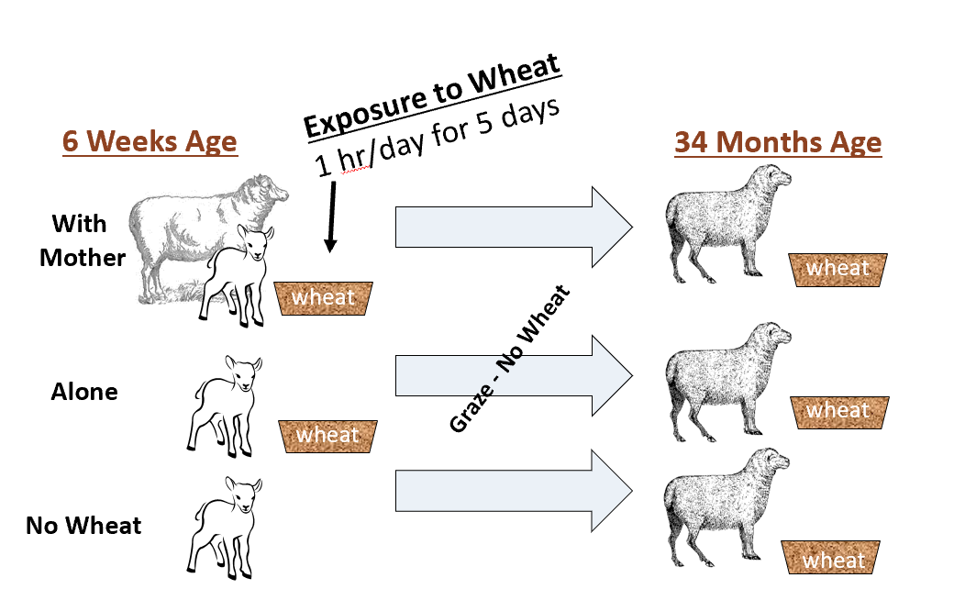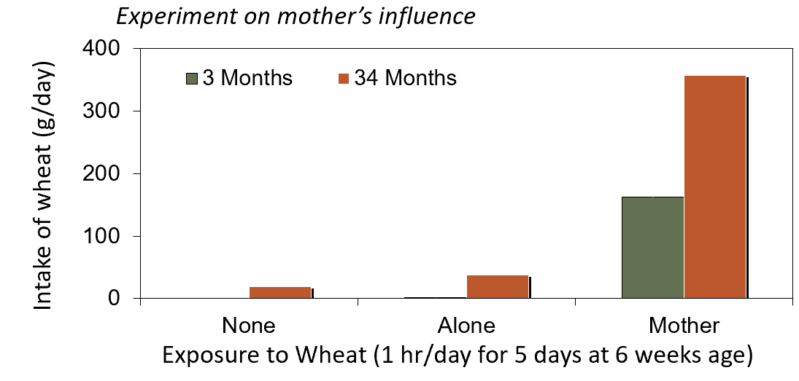

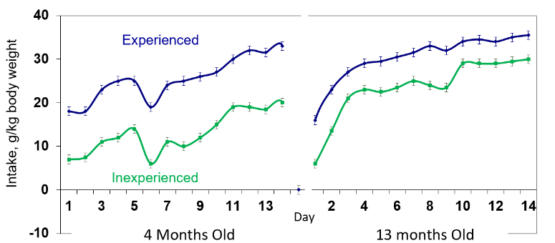
Early Life Experience is Important
Experience early in life increases intake of foods later in life
Goats - 6 weeks old
  - Experienced: raised on blackbrush range
  - Inexperienced: drylot fed alfalfa pellets
Weaned at 26 weeks
Week 28 - offered all goats blackbrush in pens

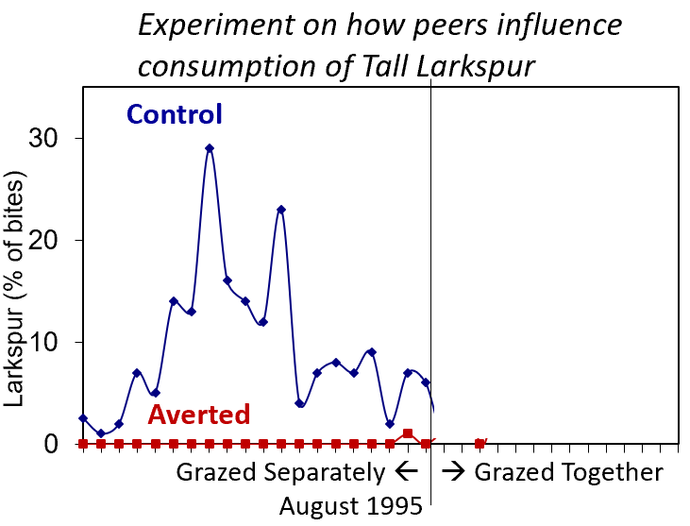
Peers also Affect Intake
For example, cows averted to larkspur ate more larkspur (% bites) when grazed cows that had not been averted

Interactions Matter
Experiences transform the body - physiology, morphology & neurology
The body then transforms experience.
And over, and over, and over

Experience affect Morphology

Experience Affects Physiology

Key Points:
- Palatability depends on __________
- Animals can detect positive & negative __________
- Animals discriminate based on ______________ interactions
  - Conditioned _________ – from positive feedback
  - Conditioned _________ – from negative feedback
- Magnitude of feedback matters
- Animals can tell what made them feel good or ill
  - Animals “blame” the ____________
- Learning from others – ___________ ________________
  - _________ is most important social model
- Animals must learn how to eat – _________
- _______ ________ experience is especially important
- Interactions matter:
  - Structure determines experience
  - Experience determines structure

More Information at: www.BEHAVE.net

References:
Coopersmith, R. and M. Leon. 1984. Enhanced neural response to familiar olfactory cues. Science 225:849-851
Distel, R.A. and F.D. Provenza. 1991. Experience early in life affects voluntary intake of blackbrush by goats. J. Chem. Ecol. 17:431-450.
Green, G.C., R.L. Elwin, B.E. Mottershead and J.J. Lynch. 1984. Long-term effects of early experience to supplementary feeding in sheep. Proc. Aust. Soc. Anim. Prod. 15:373-375.
Mirza, S.N. and F.D. Provenza. 1990. Preference of the mother affects selection and avoidance of foods by lambs differing in age. Appl. Anim. Behav. Sci. 28:255-263.
Ralphs, M.H. 1997. Persistence of aversions to larkspur in naive and native cattle. J. Range Manage. 50:367-370.
Diet Selection – Social ModelsBurritt, E.A. and F.D. Provenza. 1991. Ability of lambs to learn with a delay between food ingestion and consequences given meals containing novel and familiar foods. Appl. Anim. Behav. Sci. 32:179-189.
Flores, E. R., Provenza, F. D., & Balph, D. F. 1989. Role of experience in the development of foraging skills of lambs browsing the shrub serviceberry. Appl. Anim. Behav. Sci. 23:271-278.
Launchbaugh, K. L., & Provenza, F. D. (1993). Can plants practice mimicry to avoid grazing by mammalian herbivores?. Oikos 501-504
Provenza, F.D., J.J. Lynch and C.D. Cheney. 1995. Effects of flavor and food restrictions on the response of sheep to novel foods. Appl. Anim. Behav. Sci. 43:83-93.

