Diet Selection-Novel Foods
Integrated Rangeland Management – REM 456 – University of Idaho

Which foods to eat or avoid?
- Animals can tell what food made them feel “good” or “ill”
- Even in meals with dozens of foods
- How?

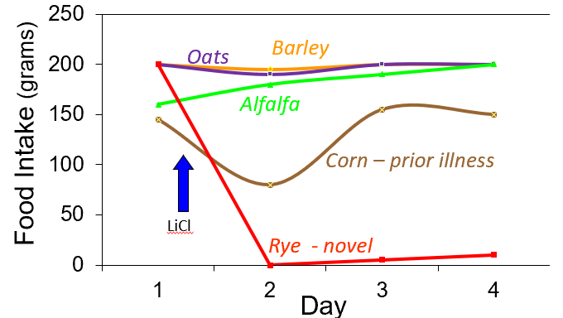
Animals sample novel foods cautiously
____________= fear of new things. Creates low intake of new foods
Video of sheep avoiding new foods: https://youtu.be/hXI4J9f3TZE
- Animals blame the novel food
- Animals avoid foods similar to foods that previously made animal ill.

Novelty is key – but other factors play a role
- ________ vs _________ Foods
Blame sickness on new foods
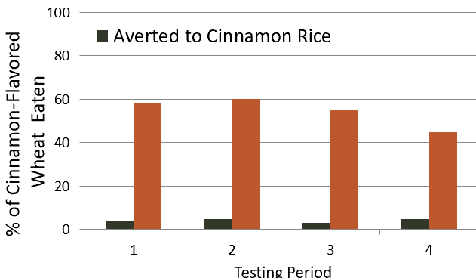
- _________ _________
Did this food make animal ill in the past?
- ____________
Is food similar to foods that made animal sick in the past?
- _________ _________
Did food make up the bulk of the diet?
- ______________
What was the last food eaten?

Animals must learn what & how to eat
- Herbivores need to learn how to eat.

Develop ____________ ______________
Animals must learn how to eat >> Video https://youtu.be/1DbUaZ3SHH8

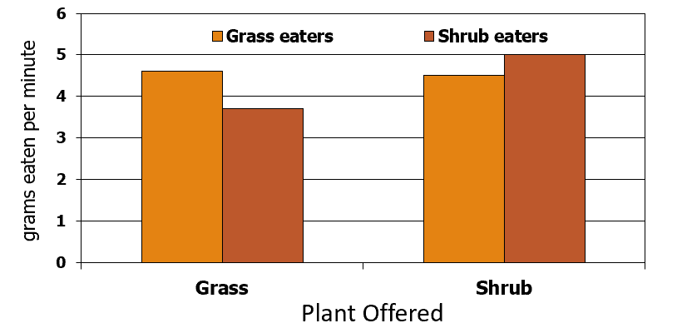
- Grass eaters vs Shrub eaters

More Info at: www.BEHAVE.net

References
Burritt, E.A. and F.D. Provenza. 1991. Ability of lambs to learn with a delay between food ingestion and consequences given meals containing novel and familiar foods. Appl. Anim. Behav. Sci. 32:179-189.
Flores, E. R., Provenza, F. D., & Balph, D. F. 1989. Role of experience in the development of foraging skills of lambs browsing the shrub serviceberry. Appl. Anim. Behav. Sci. 23:271-278.
Launchbaugh, K. L., & Provenza, F. D. (1993). Can plants practice mimicry to avoid grazing by mammalian herbivores?. Oikos 501-504
Provenza, F.D., J.J. Lynch and C.D. Cheney. 1995. Effects of flavor and food restrictions on the response of sheep to novel foods. Appl. Anim. Behav. Sci. 43:83-93.

