Forage Value of Range Plants ~ Grasses, Shrubs, and Forbs
- Integrated Rangeland Management – REM 456 –University of Idaho

Based on the most limiting nutrients on rangelands in the western U.S.
- Energy –

- Nutrients –

The 3 major factors determining nutritive value in plants:
- Cell structure: (Cell Wall: Cell Contents)
- Degree of Lignification
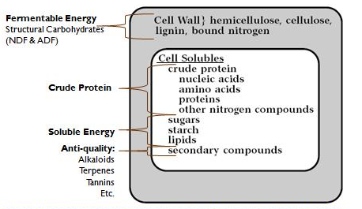
- Secondary Compounds or “Anti-quality” factors

1) Cell Structure (Wall:Contents)

- Most digestible compounds in cell contents

2) Degree of Lignification
- L that impregnates cellulose to form wood.

3) Secondary Compounds or “Anti-quality” factors
- Plants may contain secondary compounds or toxins that reduce forage quality or adversely affect the herbivore.

  - Alkaloids
  - Terpenes
  - Tannins
  - Glycosides
  - Nitrates
  - Soluble Oxalates

Comparative Nutritive Value of Plant Parts
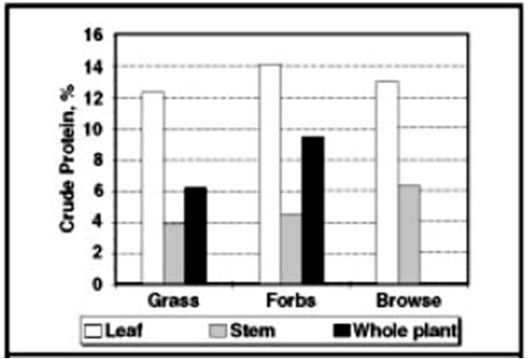
- Fruits, seeds, root-crowns and flowers are more nutritious than leaves or stems.

- Leaves are more nutritious than stems.
  - Why?

Maturation Effects on Nutritive Quality of herbaceous plants
- Most range plants are highly nutritious when young.
- As plants mature, nutritive value decreases.
Why?

- Leaching of nutrients by rain in dormancy.

Comparative Nutritive Value of Grasses, Forbs, and Shrubs
- What is browse?

- In shrubs, current season’s growth is generally more nutritious than old growth.
Why?

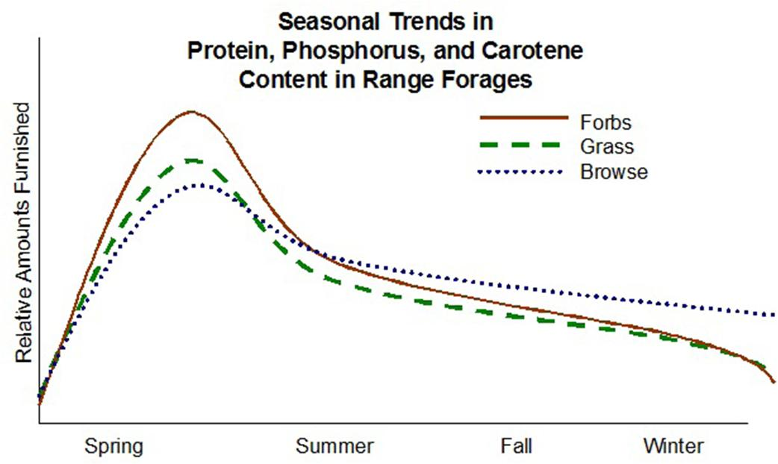
Seasonal Trends of Nutrients - graph adapted from Parker 1969

- Why are forbs more nutritious than grasses and browse?
  - Grasses

- During dormant season - browse are important for nutrients.

- The importance of shrubs for nutrient value during growing season may be more important that was once believed.
New research shows browse may be more important than we once believed.
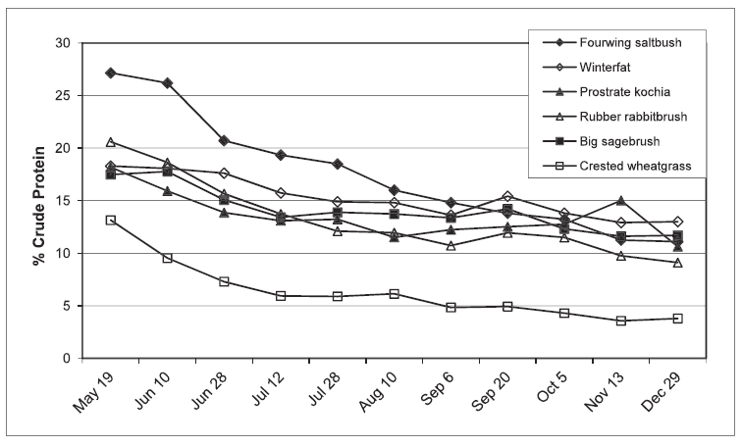

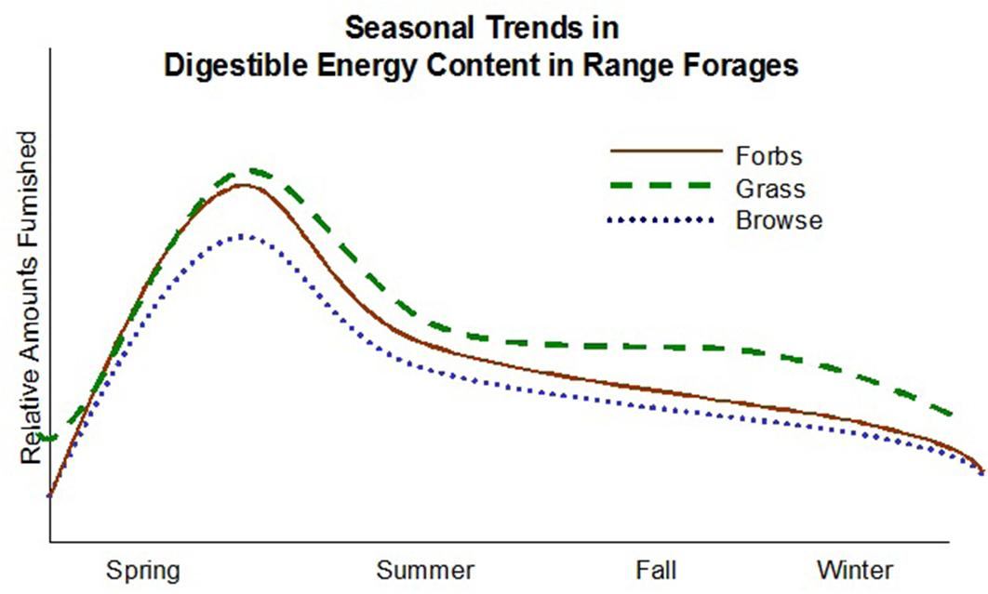
Seasonal Trend of Energy - graph revised from Parker 1969
  - During growing season - grasses, forbs, and shrubs all provide good amounts of energy

  - During dormant season - grasses provide a stable source of energy.

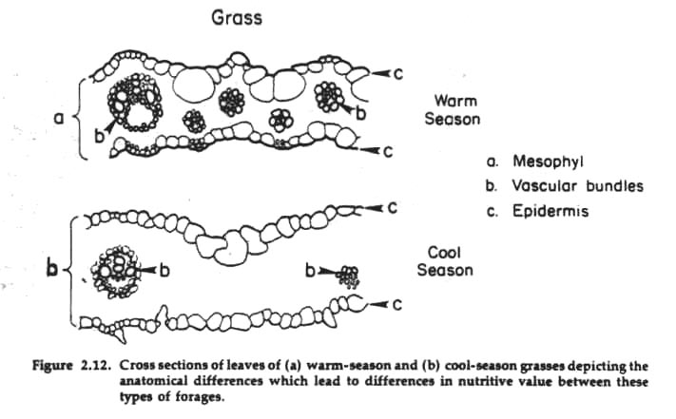
Tropical (warm season) versus Temperate (Cool Season) Grasses

Environmental Influences of Plant Nutritive Quality:
- Temperature:

- Moisture:

- Range Site:

Anti-Quality Agents:
- Most common in shrubs and forbs. (Rarely a problem in grasses).
- Resist Digestion

- Inhibit Digestion

Recap:

In Summary - Plant Management for Animal Nutrition
- Monocultures provide high quality at one time of year. This may be useful in management such as spring grazing areas.
- A variety of forage classes on range provide nutrients throughout the year:

