Fire, Grazing, & Fuels
- REM 456 – Integrated Rangeland Management – University of Idaho
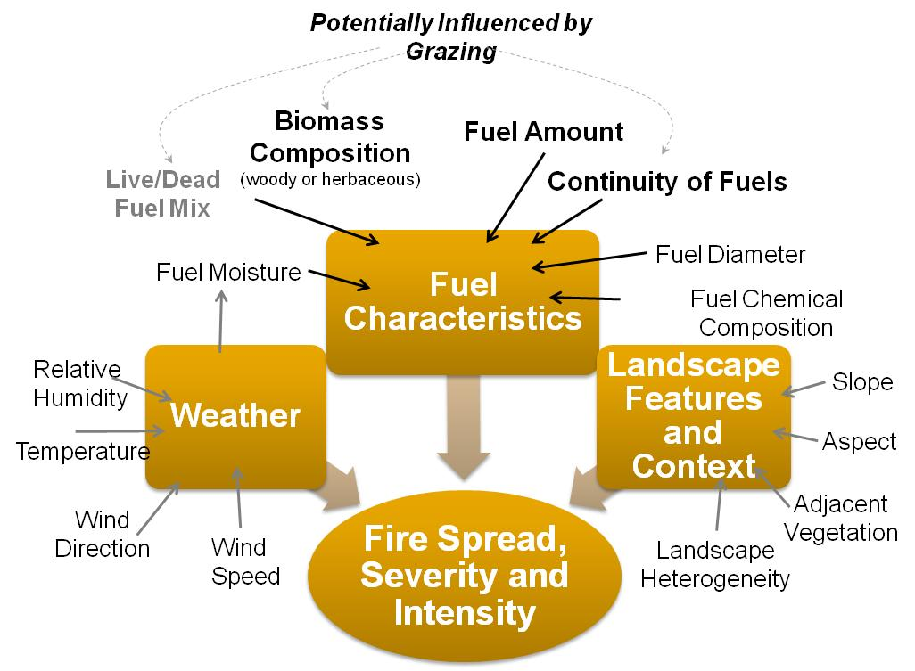
Potential Influence of grazing
- Biomass Composition
- Fuel Amount
- Fuel Continuity

Historic Patterns
- Size of wildfires increase, number of wildfires decrease.
- Livestock numbers decreasing
- Introduction of Annual Grasses – late 1800’s

- Fine textured, flammable, Early maturing
- Effect on fire:

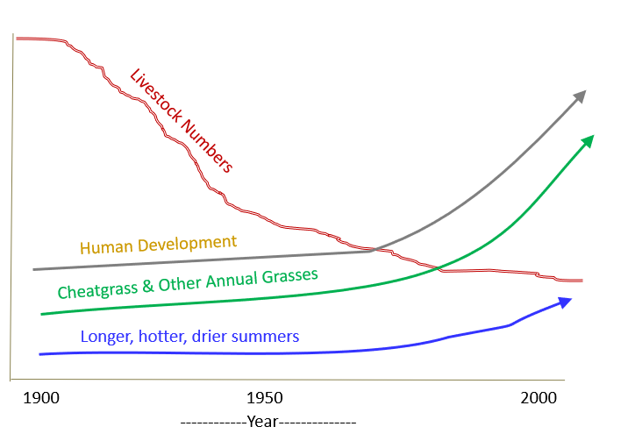
  - D

Grazing Affects Fire Behavior

Fire Behavior
- Effect of grazing potentially more effective at higher dead Fuel Moisture.
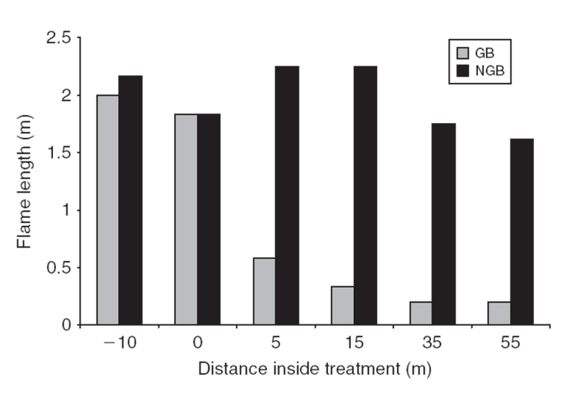
- Grazing can have an effect even if grazing occurred the season before the fire.

Cheatgrass Burning
Grazing can Affects Flame Length - Cheatgrass

Research on Managing Fuel Loads
- Grazing was influential in areas with less than 20% sagebrush cover.
- Grazing can affect fuel continuity

Grazing & Fuel - What do we really know?
- Grazing can reduce fuel loads:
  - Stop or slow fires
  - Reduce flame length
- Grazing can affect fuel even if it occurs the year before the fire.
- Grazing cannot stop fires if it is very dry and very windy

Fuel Management:
- Prevention
- Control
- Coordinate & Collaborate

