Rangeland Principles (REM 151) -–Setting Stocking Rates – Note Guide
Carrying Capacity
- The number of animals that a piece of land can support on a long-term basis without causing damage to the ecosystem.
- Expressed as animals/area/year…. usually expressed as ______________________.
Stocking Rate
- The number of animals a land manager places on a piece of land for a specified period of time.
Animal Units (AU) = 1AU = 1,000 pounds of grazing animals (ruminant)

  - Cow = 1
  - Horse = 0.56
  - Yearling Steer = 1.3
  - Sheep = 5
  - Jackrabbit = 50

Animal Unit Equivalent (AUE) = a conversion factor reflecting the # of AU in an average animal.

  - Cow = 1
  - Horse = 1.8
  - Yearling Steer = 0.75
  - Sheep = 0.2
  - Jackrabbit = 0.02

Forage Demand of Animals:
Ruminants: eat _______% of body weight/day in dry matter forage
Hind-Gut Fermenters: eat ______% of body weight/day dry matter forage
Animal Unit Month (AUM)
- Amount of forage an animal will eat in a month.
- How many pounds is an AUM?
  - Each AU = _________ lbs × 2.5% = ____ lbs/day
  - AUM = _____ lbs × 30 days = ________ lbs

Stocking Rate 4-step Method: Forage-Demand Method
- Calculate usable forage
- Adjust for terrain, water, or other constraints
- Calculate forage demand of animals
- Calculate stocking rate
Step 1: Calculate Usable Forage
- Determine biomass supply.
Wt of biomass/acre × total acres = total biomass supply
- Convert total biomass to total forage.
Total biomass/acre × Proper use (%) X area = total forage supply
Proper stocking rates are based on maintaining sufficient plant residue for:
    - Plant health/regrowth
    - Wildlife forage
    - Erosion prevention
- Example: You manage a 1,200 acre ranch and the average production is 500 lbs/acre. The ranch is located in a sagebrush steppe plant community and has a proper use factor of up to 30% of the annual forage. What is your forage supply/year?
_______ acre ranch ×_______ lbs/ac = __________ lbs of biomass
× _____ Proper Use Factor = ______________ lbs of forage.
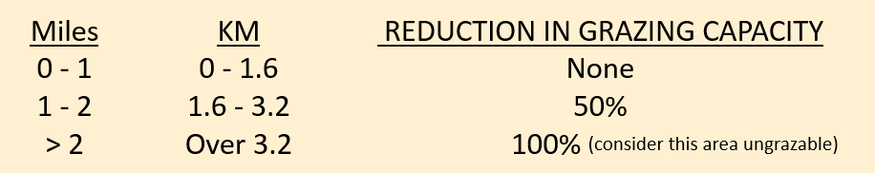
Step 2: Adjust for Accessibility
Not all forage is available for grazing.
- How far from water?
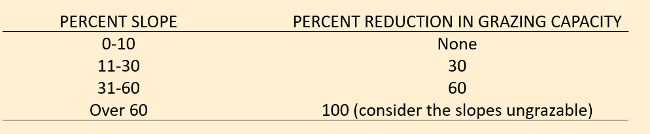
- How steep?

Step 3: Calculate Forage Demand
Body weight × ___% eaten/day = amount eaten/day × days on range = total amount eaten
Example: On average cows in your herd weigh 1,000 lbs and graze on the ranch for 3 months How much forage would you expect each cow to eat?
_______ lb cow X _______ % of body wt/day = __________ lbs forage/day
25 lbs X _____ days = _________ lbs/cow/season.
OR… How many AUMS is this?
______ lbs/cow/season ÷ ______ lbs /AUM = _____ AUMs
Step 4: Calculate Stocking Rate = Number of animals/area of land/season
Example: How many cows should you have in your base herd if your usable forage is ______ lbs/pasture and the forage demand of each cow is _____ lbs?
________lbs supply ÷ ________ lbs demand = ________cows
_______AUMs supply ÷ _______ AUMs demand = ______ cow

