REM 151 - Animal Behavior on the range – Note Guide
What affects how animals behave:
- Born with certain abilities
  - _________________ .
  - _________________ .
- Born knowing what to do:
  - _________________ .
  - _________________ .
- Inherited Abilities
  - _________________ .
  - _________________ .
  - _________________ .
  - _________________ .
  - _________________ .
  - _________________ ..
- Inherited Behaviors – Instincts
  - _________________ .
  - _________________ .
  - _________________ .
 | “Good” Consequence | “Bad Consequence”
Add or Apply | Behavior Increases  (Positive Reinforcement) | Behavior Decreases  (Positive Punishment)
Remove | Behavior Decreases  (Negative Punishment) | Behavior Increases  (Negative Reinforcement)
- Basic Learning Paradigms

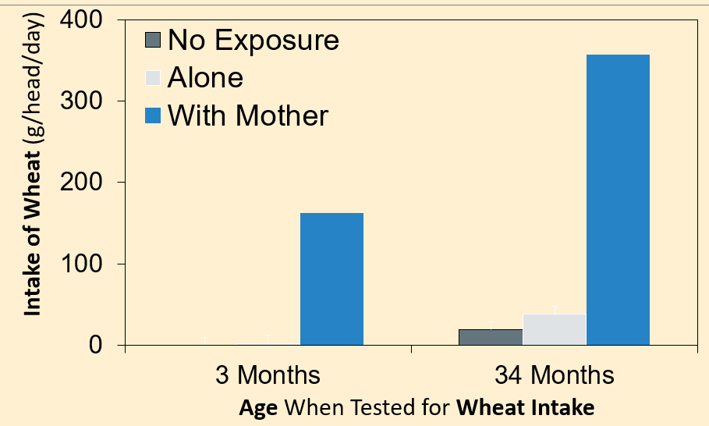
Young animals clearly learn what to eat avoid from their mother

Early Life Experience is Influential
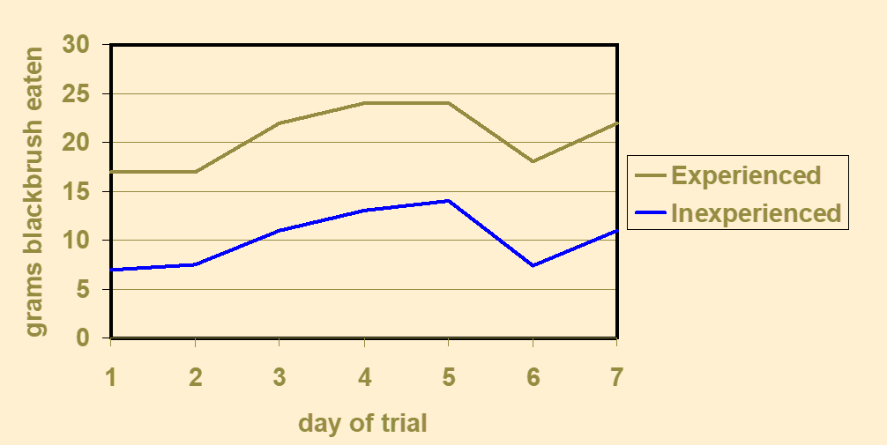

Animals must learn how to eat - Build Foraging Skills
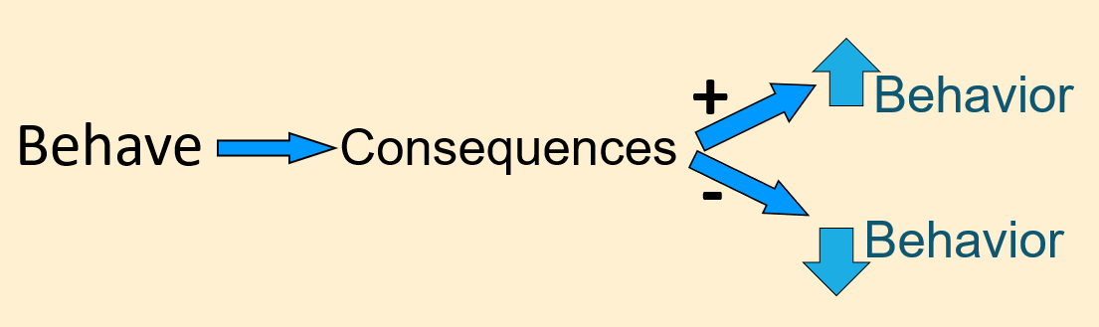
Animals learn based on consequences:

Conditioned Aversions & Preferences
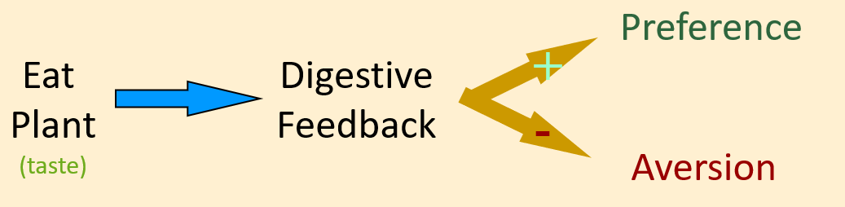
How to create a conditioned aversion?

Why don’t livestock eat sagebrush?

How to create a conditioned preference?

Nutrient-Toxin Interactions:
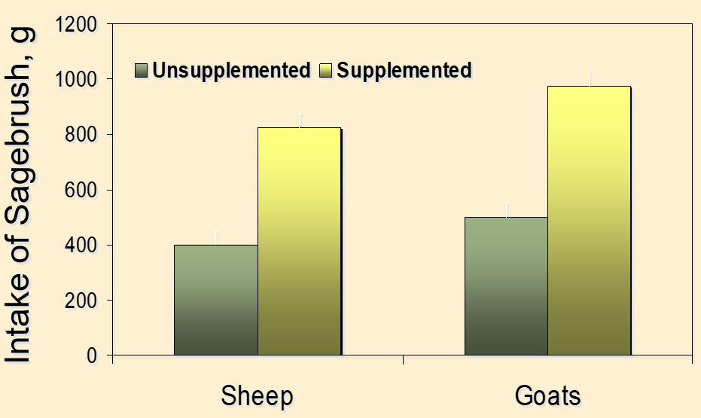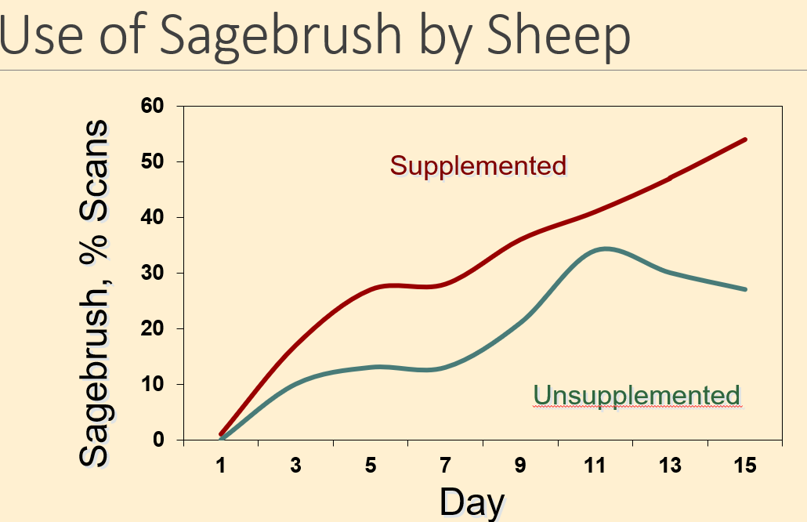
Creating “Designer” livestock
- Select animals that naturally possess the desired ingestive characteristics
- Breed animals with these abilities
- Prepare animals with prescribed dietary experience
- Offer animals nutritional or pharmaceutical resources to aid in digestion or detoxification
For More information: https://extension.usu.edu/behave/

