Managing Working Landscapes
Planning and Management Challenges
- Managing Across Land Ownerships
  - All Hands-All Lands
  - Collaborative Resource Management
- Managing Multiple Use
  - Value of land varies across landscapes
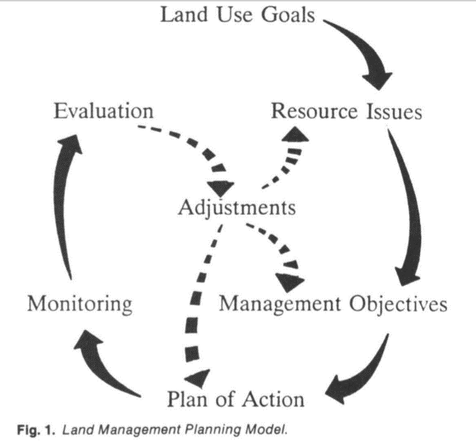
  - Value changes throughout the year
- Managing for Outcomes
  - Consider ecological, economic, and social outcomes
  - Avoid prescriptions

Many Approaches – A few common elements.
Individually or Collaboratively…
- _________________
- _________________
- _________________
- _________________
Managing Across Land Ownerships
- Natural processes happen across land ownerships

  - Fire
  - Wildlife
  - Water
  - Weeds
  - __________
  - ___________

- Management should occur ________________________
→ All Lands Approach
- Groups come together to manage a resources/value
  - _____________________________
  - _____________________________
  - _____________________________
  - _____________________________
- Focus on common goal
- Bring diversity of skills & resources
→ Collaborative Resource Management

Managing Multiple Uses
- Manage various resource values in combinations that best meet the present and future needs
  - Consider interactions _____________________________
  - Apply restrictions and enhancements to _____________________________
  - Public/cooperator involvement necessary
- Required on federal lands by ______________________________________ of 1976.
- Applied on private lands to make operation sustainable.
→ Multiple Use Management

- Not every use on every acre
- Use changes throughout the year

Outcome Based Management
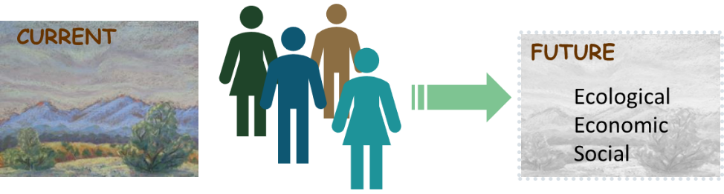
- Focus on Outcomes
  - ______________
  - ______________
  - ______________
- Avoid prescriptions
  - Specific number
  - Specific time
→ Outcomes Based Land Management

- Collaborative at Landscape Scales

- Sustainable working landscapes that provide diverse goods and services for people who live, work, and recreate on the land.

