Riparian and Wetland Ecosystems
Rangeland Principles – REM 151
- Uplands:
- Riparian:
  - Lotic
  - Lentic
- Wetlands:

- What is a Watershed?
  - A surface water designation
  - The area that flows into a distinct drainage (i.e., stream, river, creek, pond)
  - Separated from other watershed by ridge-top boundaries.
  - Watershed are segments of larger-scale River Basins

What characterizes Healthy Riparian Area?

What characterizes Degraded Riparian Area?

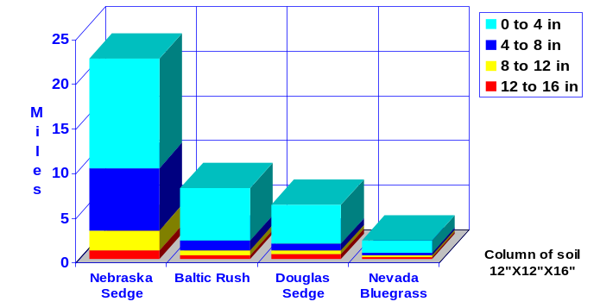
Riparian Plants – Are Important
- Underestimated for potential to “control” stream systems
- Large Woody Debris or Rocks/Boulders usually considered first
- Plants mold the stream to fit power of water.
- Root Length is Significant
Beavers are Important “bio-engineers”

Important Riparian Plants
- Baltic Rush – Perennial Native Grass-like Plant
- Nebraska Sedge - Perennial Native Grass-like Plant
- Coyote of Sandbar Willow - Perennial Native Woody Plant
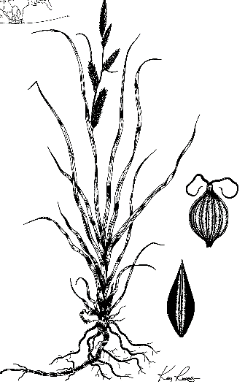
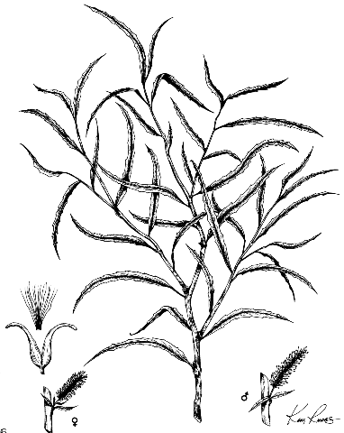
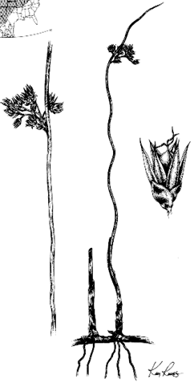
Nebraska Sedge
Coyote Willow
Baltic Rush

Important Riparian Animals
- Beaver – Native mammal
- Columbia Spotted Frog – Native amphibian once listed under the endangered species act but “delisted” or removed from the ESA list in 2015
- Bull Trout – Native fish – listed as “threatened” under the ESA
