Ecosystem Production
- Food Chains and Biomass Pyramids on Rangelands
- Trophic Levels
  - Feeding levels with respect to primary source of energy
  - Producers & consumers each occupy a different trophic level
  - Energy is lost at each level
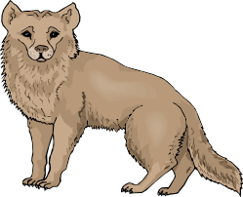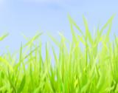
1st Trophic Level
Producers
Plants
2nd Trophic Level Primary Consumers
Herbivores
3rd Trophic Level Secondary Consumers
Carnivores
Heat
Heat
Decomposer
- Biomass Pyramids
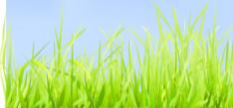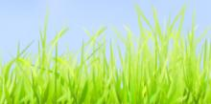
At each level
some biomass is not passed
to next higher level
1st Trophic Level
Producers
Plants
2nd Trophic Level
Herbivores
3rd Trophic Level
Carnivores
Heat
Decomposer
Heat
- Biomass Pyramid
  - The total weight of all living organisms
  - Biomass at each trophic level
biomass pyramid
Biomass pyramid
(grams/m²)
809
37
11
1.5
Producers
Herbivores
Primary carnivores
Top carnivores
Detrivores/
decomposers
5
- Biomass decreases at higher trophic levels
  - Not all biomass is consumed from one trophic level to next

- Vegetarian Solution?
  - Shorter food chain/web = less loss of energy
    - Vegetarianism results in a decrease of human position on food chain.
    - Is vegetarianism is the best way to feed a large population?
Will this solve the world’s food security?
- Two Good Reasons
- 1) Cellulose most abundant, naturally occurring organic molecule on earth

- 2) Only about 10% of the earth land surface can be farmed.

