Invasive Plant Management - Rangeland Principles (Note Guide)

Why Care? … The spread of noxious weeds:
- Signal ecological decline of entire watersheds.
- Reduce beauty and biodiversity of natural areas.
- Cause widespread economic losses in agriculture and recreation.
- Problem for all lands: urban, rural, private, state, and federal lands.
- Noxious weed species spare no segment of society—rancher, farmer, fisher, and cycler alike
- Can’t leave well enough alone - when unmanaged, they spread rapidly, unceasingly, and silently.
Invasive/Noxious Weeds:
- https://www.cals.uidaho.edu/edComm/pdf/bul/bul0816.pdf
- http://invasivespecies.idaho.gov/control-strategies/
- http://www.idahoweedawareness.net/vfg/weedlist/weedlist.html

Exotic Invasive Species – more than just plants
- Animals (e.g., wild boar, starling)
- Insects (e.g., fire ants, killer bees)
- Microbes (e.g., white nose syndrome in bats, chestnut blight)
- Viruses (e.g., zika virus, west nile virus)
Why are Weeds Bad… or Good
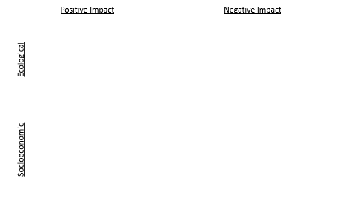
What can be done?
- Prevention: __
- Early Detection and Rapid Response
- Eradication: __
- Control:
  - biological: introducing a natural enemy, predator or parasite
  - chemical: pesticides, herbicides, and fungicides
  - mechanical: physically removing the invasive species or changing the habitat conditions
- Research: provides the basis for invasive species action
- Restoration: minimize the chance an area will be reinvaded
- Education and Public Awareness
Land Planning with Weeds
- Prevention
  - Consider__
  - Develop __
  - Minimize __
- Early Detection
  - Develop __
  - __
Maintain Healthy Plant Communities
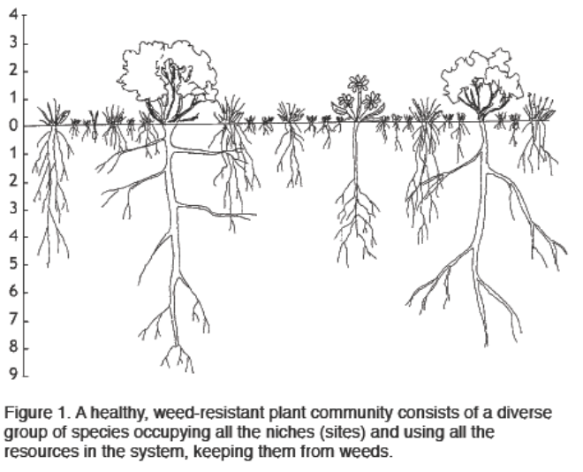
Weed Control Approaches
Chemical Control – Proven uses of herbicides on rangelands:
- Control __
- Increase effectiveness of __
- Rejuvenate __
- Eradicate _
- Eradicate _
- Kill existing community to _
- Maintenance control or retreatment when _.
Mechanical - removal or damage to weeds with physical/mechanical forces
- Brush Sculpting
- Chains
- Shredding/Mastication

Biological - suppress weeds with living organisms including parasites or pathogens.
…the planned use of living organisms to reduce the vigor, reproductive capacity, density, or effect of weeds…
Requirements necessary for biological control agents to be successful:

Cultural - alter land management practices (fertilize, cultivate, graze, burn) to suppress weeds
- Targeted grazing =
What can be done?
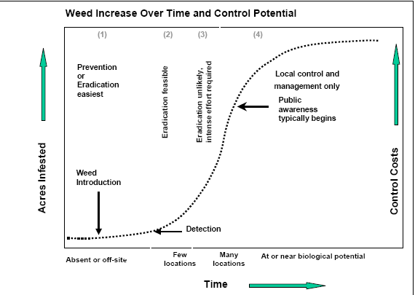
Weed Survey

Weed Mapping

Integrated Weed Management = Mechanical + Chemical + Biological + Cultural = Keep weeds to manageable level with individual or combination of techniques
Coordinated Weed Management Groups
  - Develop plans across land ownerships
  - Leverage resources
    - Time
    - Equipment
    - Money
    - Expertise
  - Apply for state and federal funds
Monitoring and Evaluation

Steps to Follow for Weed Control:
- Prioritize goals:
  - Do you aim to eradicate or merely contain an infestation?
  - Which weeds are your highest priorities in the short-vs. long-term?
  - What are the potential impacts of the various weeds that you may treat?
  - Which weeds are listed on federal, state, or county noxious weed lists?
- Monitor:
  - Carefully follow the progress of your efforts and make corrections to your activities as needed.
  - Follow-up treatments can be applied as necessary
- Revegetation:
  - It is important that while you want to rid an area of invasive plants, you also want to promote restoration of native plant communities.

