Grazing Methods & Systems
Rangeland Principles Note Guide

What can grazing methods accomplish?
- Maintain or accelerate vegetation improvement.
- Improve uniform use of all grazing units.
- Stabilize the forage supply throughout the grazing season.
- Enhance forage quality for livestock and wildlife.
- Improve function of ecological processes.
- Protect watersheds.
- Enhance wildlife habitat.
Terms of Grazing Methods:
- Grazing Systems =
- Grazing Period =
- Deferment =
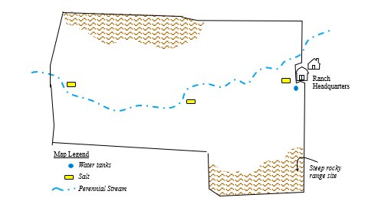
- Rest =
------------- Basic Grazing Methods--------------
Continuous Grazing: Grazing the whole area for the whole grazing season.
Pros:
+
+
Cons:
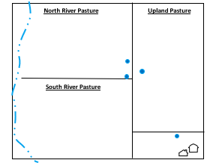
-
Deferred Rotation: Do not graze at least one pasture until after it has set seed (defer). In subsequent years, change the pasture deferred so the deferment is rotated among all the pastures over years.
Pros:
+
Cons:
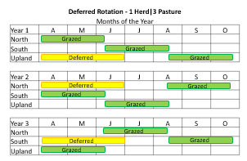
-
-

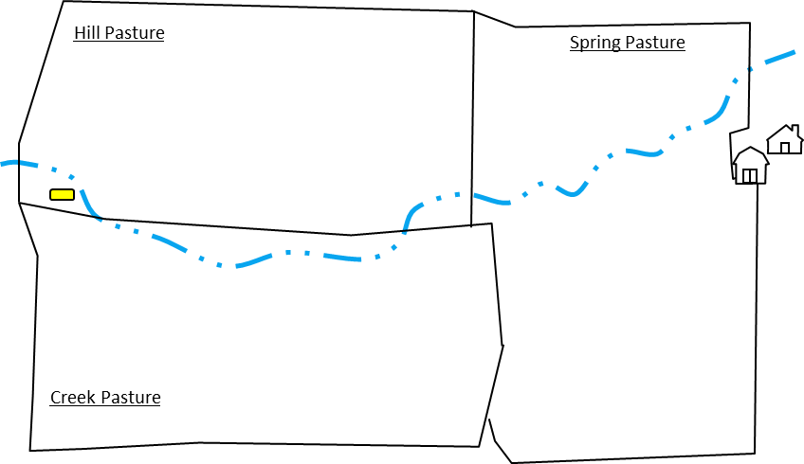
Rest Rotation: Do not graze at least one pasture for a whole year (rest). In subsequent years, change the pasture rested so rest is rotated among all the pastures.
Pros:
+
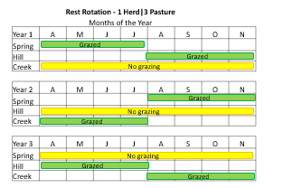
Cons:
-

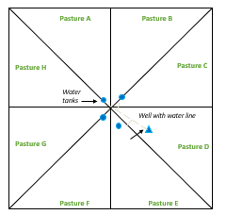
Short-Duration: Each pasture in the unit is grazed for a short time and animals are rotated through all available pastures so that each pasture is grazed at least two times per year.
Pros:
+
+
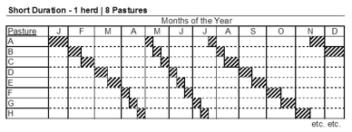
+

Cons:
-
-
Seasonal-Suitability: Moving livestock to different areas of range depending on growth patterns of different vegetation types (i.e., following the green). Pros:
+
+
+

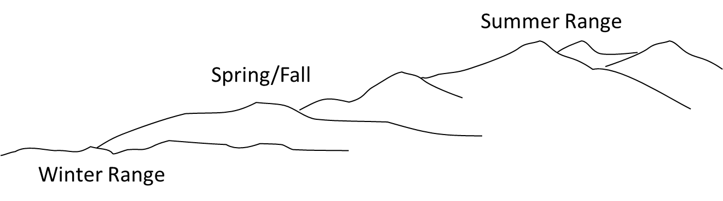
Cons:
-
-

-------------Decisional or Management Intensive --------------------
Best-pasture system: Move livestock to pasture that looks the “best” in terms of forage availability.
Complementary system: Designed in the central plains where animals rely on:
Seasonal-suitability: Movement of livestock to different areas of range depending on
Which system is best?
- There is no “silver bullet” system that will work everywhere.
- There are thousands of variations on a theme…
- All systems need to be flexible to manage unexpected disturbance such as fire or weed invasions.
- Success of grazing systems depends on:

  - ___________________
  - ___________________
  - ___________________
  - ___________________

- No matter the system—stocking rate, species of grazing animal, and distribution patterns—are important in determining how the systems affect vegetation communities.
Effect to Consider

Continuous:
- Livestock production?

- Riparian condition?

- Wildlife?

- Wildland Fuels?

Deferred Rotation:
- Livestock production?

- Riparian condition?

- Wildlife?

- Wildland Fuels?

Rest-Rotation:
- Livestock production?

- Riparian condition?

- Wildlife?

- Wildland Fuels?

Seasonal Suitability:
- Livestock production?

- Riparian condition?

- Wildlife?

- Wildland Fuels?

