Rem 151: Adaptive Management
Objective 1: Differentiate simple and complex problems
Simple: ‘‘Simple’’ problems are defined as those in which the input variables and the relationships between those variables are, for all practical purposes, constant.
Simple problem –
Simple solution –
Complex: Problems become “complex” when input variables are not constant and/or when the relationships between those variables are dynamic across space and time
Complex problem –
Complex solution –
Objective 2: Examine the importance of evolutionary (i.e. continual) knowledge acquisition in addressing complex problems.
Adaptive management
We have a problem!
1.
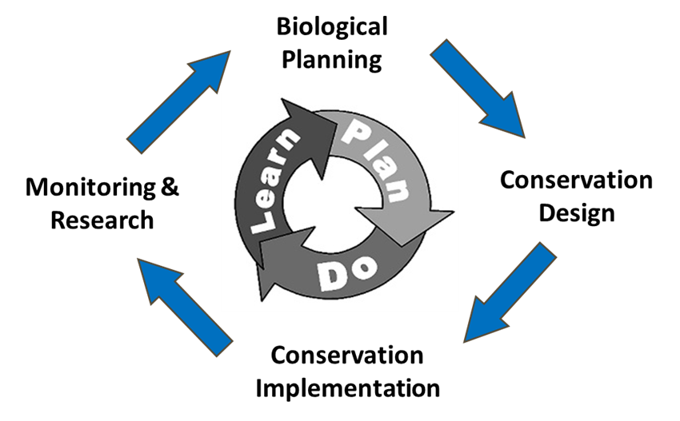
2.

3.

4.

5.

Objective 3: Barriers to adaptive management of complex problems
Programmatic success vs. biological success
Conservation Partner Ecosystems
Ecological Frameworks
Rangeland Management in Space and Time

