Flowers and Inflorescence Types

Be able to recognize the following plant parts and terms to describe plants.
References pages are listed North American Wildland Plants Book (by Stubbendieck, Hatch & Landholt)

Flowers and Reproduction

Four stages of flower reproduction

Structure of Flowers

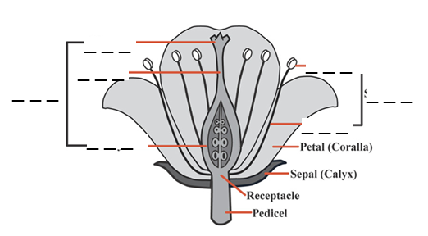

- Female or Pistil

  - Style
  - Stigma
  - Ovary

- Male or Stamen

  - Anther
  - Filament

Perfect Flowers =

Imperfect Flowers =
- Monoecious =
- Dioecious =

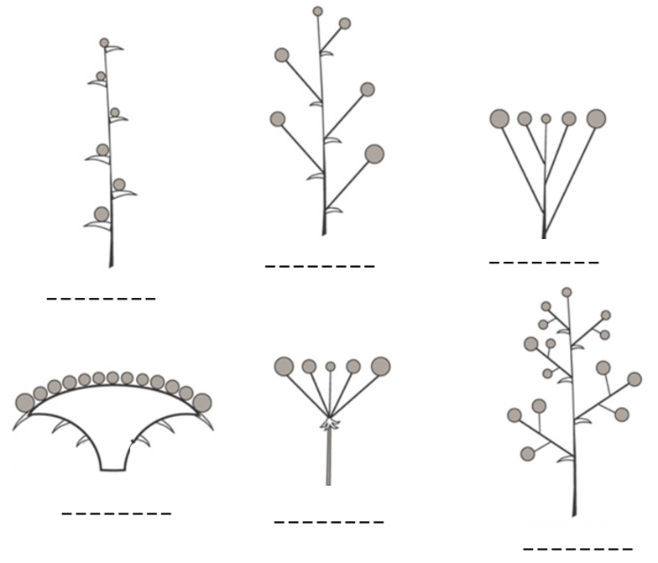
Types of Inflorescences (pg 23-24 in brown text)
- Spike →
- Raceme →
- Panicle →
- Umbel →
- Corymb →
- Head F →

- Catkin = a dense spike or raceme with many small, usually naked, flowers.

- Cyme = a convex or flat-topped flower cluster with the central flower first to open.

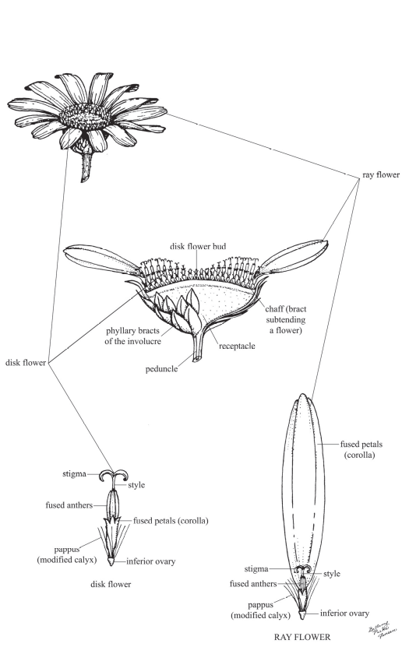

Head (another type of Inflorescence)
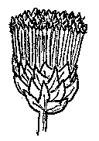
- Composite Heads



Ray & Disk flowers →
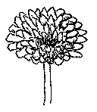
Ray flowers only →
Disk flowers only →

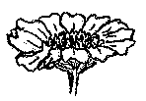

Identification Practice
Inflorescence Types:

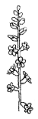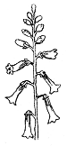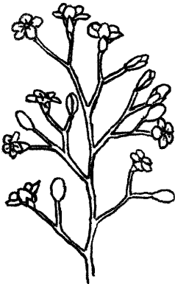

________________ _______________ _______________

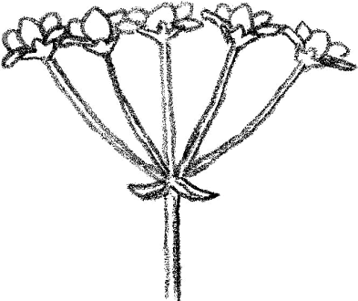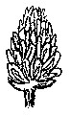

______________ _________________

Composite heads:



  

