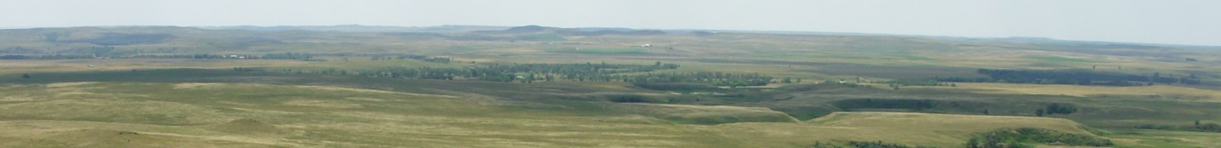
Great Plains Grasslands

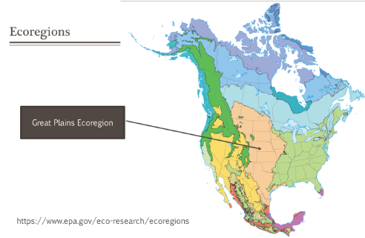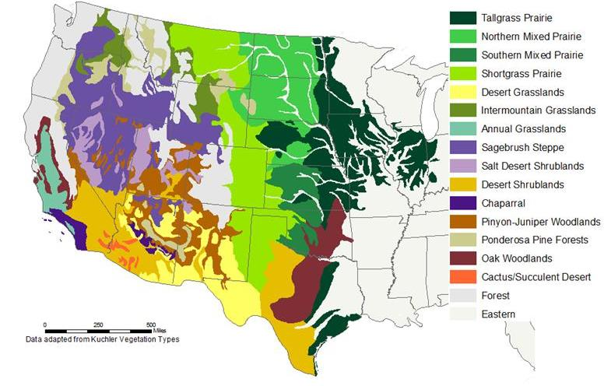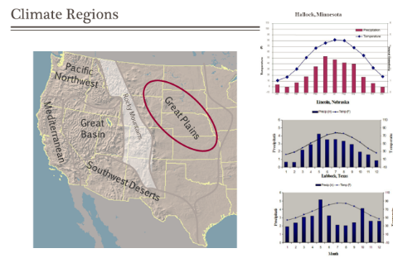

Tallgrass Prairie:
- Significant moisture during growing season – 20-30” annually
- Fire are important in maintaining the grasslands – reduce shrub invasion
- This prairie evolved with grazing and major grasses are adapted to grazing
- Grasses created very productive soil (rich Mollisols) were easily plowed, converted to croplands
- Only about 5% remaining of what originally existed
  - Konza Prairie in Kansas is one of the largest remnants

Mixed Prairie:
- The Mixed prairie is a mix of:
  - Tall, mid- and short grasses
  - Cool season and warm season plants
  - Mix of plant communities on landscape
- Annual precipitation = 14-20” mostly in summer
- Wetlands important for migratory waterfowl (i.e., Prairie Pothole & Playas)
- Plants evolved with grazing by bison – plants well-adapted to grazing
- Wildfires were historically common

Shortgrass Prairie:
- Low rainfall. Annual Precipitation =12-20”
- In rainshadow of Rocky Mountains
- Native plants well adapted to drought and heavy grazing
- Fire is not a major force ─ not enough biomass for large fires
- Signature short grasses = blue grama and buffalograss

