What are Rangelands?
What are Rangelands?

- Deserts -
- Tundra -
- Wetlands -
- Savannas -
- Shrublands -
- Forests -
- Grasslands -

- Forage pasture?

PASTURELAND is differentiated from rangeland by the fact that periodic cultivation
is used to maintain introduced (nonnative) forage species, and agronomic inputs such as irrigation and fertilization are applied annually.

Wild Open Spaces
- Grasslands, shrublands, woodlands, deserts, savannas, tundra, steppe, and prairies.

All areas of the world that are not:

Shrublands, grasslands, and open forest where several factors preclude farming or timber production:

- precipitation

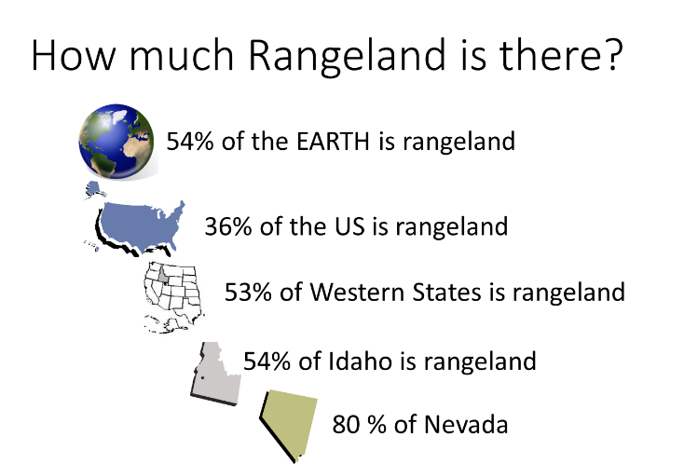
Are all rangelands grazed?

  - Rangelands are a kind of land – not a specific land use.

rather than agronomic) principles.

Why are rangelands important?
They cover a lot of ground!

___% = Rangeland
___% = Dense Forest
___% = Cropland
___% = Urban
___% = Ice, rocks and barren lands

Rangeland are Important -for many resources:

Forces that Threaten Rangelands.

