Guidelines for Setting a “Proper” Stocking Rate

Four Grazing Management Factors:
- Which animal? -Animal Species & Class
- How many animals? -Stocking Rate
- When to grazing or not graze? -Grazing System
- Where animals graze? – Grazing Distribution
Carrying Capacity= Number of animals a piece of land can support long-term without causing damage to the ecosystem.
•
•
•
Stocking Rate =The number of animals a land manager places on a piece of land for a specified period of time
  - Must include:
▪
▪
▪
  - Most important grazing decision because it affects:
▪
▪
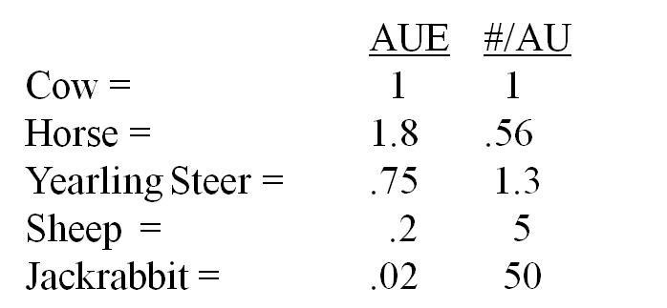
Animal Unit (AU) = 1,000 pounds of grazing ruminant animal.
An AU in NOT and animal. It is an amount of animal(s)
Animal Unit Equivalent (AUE) = A conversion factor reflecting the # of AU in an average animal
- Forage Demand of Animal
  - Ruminants
    - Eat _______% of body weight/day in dry matter of forage.
    - Cattle, sheep, goats.
    - Deer, elk, bighorn sheep, moose, etc.
  - Hind-Gut Fermenters
    - Eat 3-6% of body weight/day in dry matter of forage.
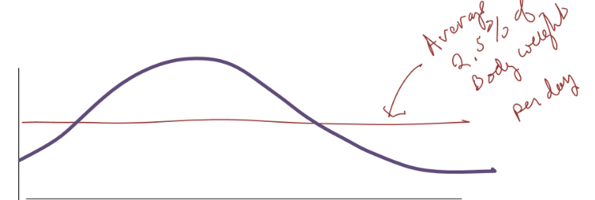
    - Horses, rabbits, and rodents.
- Amount of Forage Eaten
  - Demand = animals eat more during period of high demand

▪
▪ 
  - Forage Quality = animals eat more when forage is of high quality and digestible
▪
▪

Animal Unit Month (AUM) - Amount of forage an AU eats in a month
    - How much is an AUM?
Each AU = ___________lbs ×____% BW eaten each day = _____ lbs/day
AUM= ______ lb * 30 days in a month = _____ lbs

Proper Stocking Rate? Range Health Standpoint

Basis for Stocking Rates
Proper stocking based on maintaining sufficient plant residue for:
•
•
•
Set stocking rate below carrying capacity
•
• 
•
• 

Utilization Guidelines: Based on ecological research
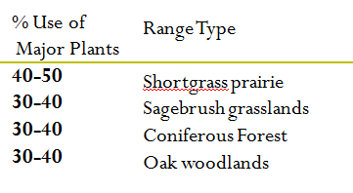

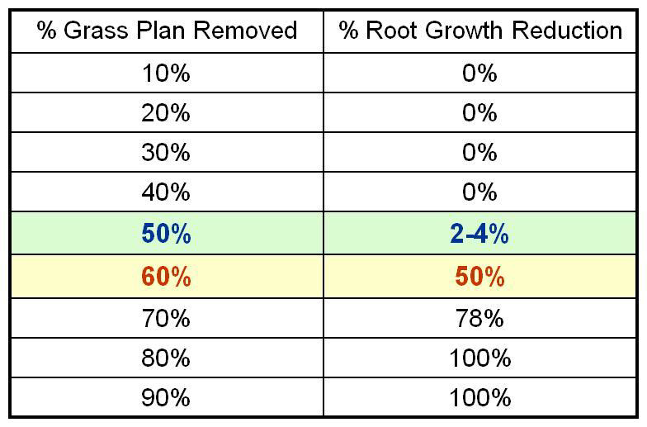
- Root Responses to Defoliation

Utilization guidelines should not be hard and fast rules.
Effects of defoliation or utilization depend on:
• __________________________
• __________________________
• __________________________
• __________________________
Basis for “Allowable Use” or “Recommended Use” Levels
Total Forage × Recommended Use = Usable Forage Supply
For Example: 1,000 lbs/ac forage × 45% recommended use = 450 lbs/ac of usable forage

Heavy use ≠ Overgrazing – Overstocking (or heavy stocking) does not always lead to overgrazing
Overgrazing =

Overstocking =

For Rangeland Health -- Set Stocking Rates Below Carrying Capacity
•
•
•
•
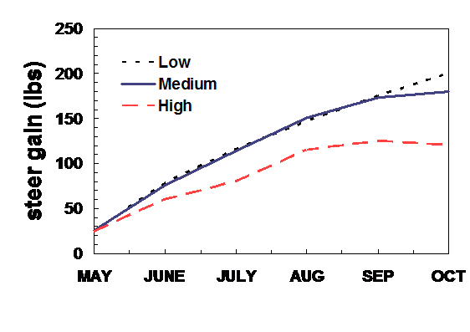
Proper Stocking Rate? Animal Production Standpoint

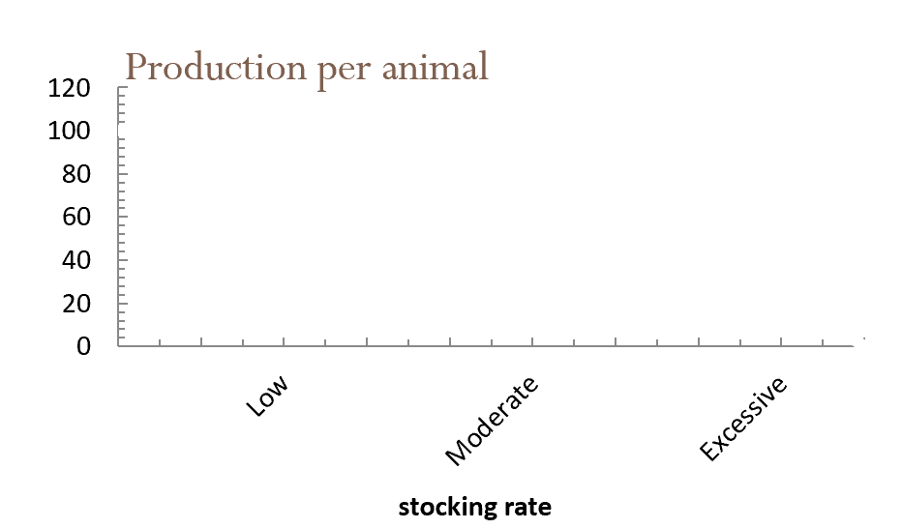
Stocking rate affects cattle gains:

Stocking rate affects production per acre:
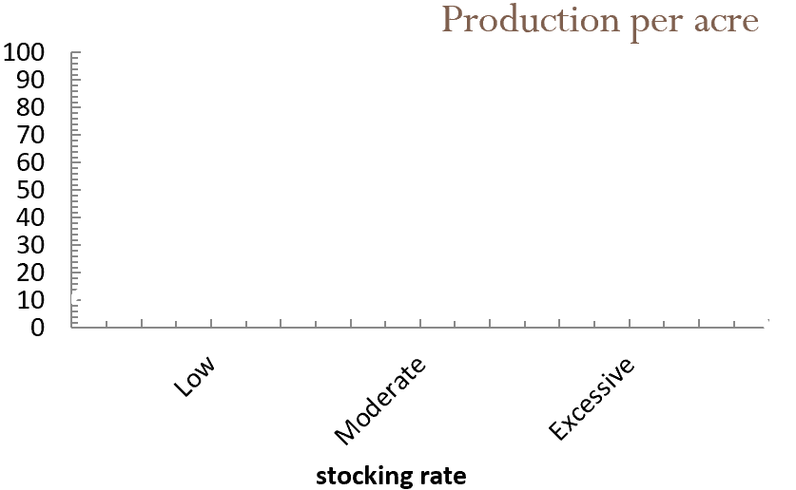

For Livestock Production: Set Stocking Rates at or Below Carrying Capacity

Proper Stocking Rate? Economic Standpoint

Fixed costs of production don’t vary with amount produced:
•
•
•

Variable costs of production increase with amount produced:
•
•
•
•

Effect of costs on stocking rate:
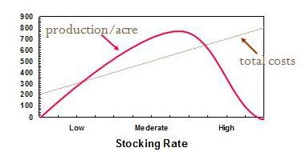

Net Revenue from Grazing affected by:
- Annual forage production
- Livestock production per year (lbs/acre)
- Market price
- Production costs
  - Fixed
  - Variable

Summary of Carrying Capacity and Stocking Rates

A stocking rate based on:
  - Range Health:
Stocking Rate _______________ Carrying Capacity

  - Livestock Production:
Stocking Rate ______________ Carrying Capacity

  - Economic Returns:
Stocking Rate _____________ Carrying Capacity

Why does overgrazing still occur?
•
•
•
•

